(TBC) Title: Predictive Modeling of COVID-19 Variant Peak Prevalence and Duration Using GISAID Data Across 15 Countries

Authors (TBD): Franky Zhang, Rob Paton, Jaehun Jung, Chris Overton*, Youngji Jo*

Abstract

Background: Rapid emergence and replacement of SARS-CoV-2 variants underscore the need for early and reliable indicators of variant dominance to guide timely public health response. However, early genomic trajectories are typically short, sparse, and noisy, with strong fluctuations and substantial heterogeneity in sequencing practices across countries.

Methods: We developed a scalable, sequence-only forecasting framework to predict which variants will dominate and how long they will persist using early genomic growth patterns alone. More than nine million SARS-CoV-2 sequences from 15 countries (GISAID, 2020–2024) were analyzed. Variant dominance was characterized by monthly peak share and duration above 10% prevalence. Using the first 2–4 weeks after a variant reached 1% frequency, we extracted handcrafted growth features and Rcatch22 time-series descriptors. Multiple models—including GLM, GAM, SVM, CART, Elastic Net, and a SuperLearner ensemble—were trained and evaluated using RMSE, R², accuracy, and macro-F1, with SHAP analysis for interpretability.

Results: The Super Learner ensemble model achieved the best performance, achieving up to 0.85 accuracy for peak-share prediction, and up to 0.77 accuracy for duration classification—substantially outperforming all individual models. SHAP analysis showed that variants achieving high peaks exhibit strong but structurally coherent early growth, whereas prolonged dominance is associated not with early surges but with sustained, moderate short-term fluctuations embedded within a stable trajectory.

Conclusion: This framework defines minimum surveillance thresholds (≥100 sequences in 30 days, ≥1% detection share), variant grouping rules, and noise-filtering protocols, enabling cross-country comparison and country-specific forecasting. It provides a lightweight, reproducible early-warning tool for genomic surveillance and real-time epidemic intelligence.

Introduction.
The SARS-CoV-2 pandemic has provided a unique opportunity to observe viral evolution and competition in real time, offering insights into broader respiratory pathogen dynamics (Harvey et al., 2021). As variants have demonstrated clear patterns of emergence, dominance, and replacement, this viral succession has created a natural experiment in pathogen evolution. Identifying early indicators of dominance carries profound implications for public health planning, including vaccination strategies and resource allocation. Consequently, global health organizations like the Centers for Disease Control and Prevention (CDC) and the World Health Organization (WHO) have emphasized that SARS-CoV-2 variant surveillance remains critical for pandemic preparedness .
Despite the global experience of multiple SARS-CoV-2 infection waves, timely identification of variants capable of driving new surges remains difficult due to several intertwined factors. Capturing early signals of variant dominance is particularly challenging because early trajectories are short, sparse, and noisy, with strong daily fluctuations and large cross-country variation in sequencing practices. Defining the initial observation period is also delicate including too many early zeros or stochastic spikes can distort growth signals and obscure true trends. Moreover, the virus’s high mutation rate continually generates a diverse pool of variants with distinct genetic profiles that affect transmissibility, immune escape, and pathogenicity, complicating efforts to identify which low-prevalence lineages (e.g., 0.01–3%) are likely to dominate. The challenge is compounded by variability in sequencing capacity across countries, with low-resource settings often facing delays in generating sufficient genomic data to detect emerging variants early. For instance, while high-sequencing settings (~1,000 sequences/week) enable robust monitoring, regions with limited infrastructure (~100 sequences/week) often face detection delays and incomplete genomic coverage. Recent analyses show that 78% of high-income countries sequenced over 0.5% of their COVID-19 cases, compared with only 42% of low- and middle-income countries . Recent advances in machine learning–based forecasting have addressed parts of this problem but still leave critical gaps. Hamelin et al. (2025) showed that deep learning and protein language models can predict viral evolution and immune escape before variants emerge, facilitating anticipatory vaccine design but requiring rich molecular and structural datasets. In contrast, Chowell and Skums (2024) integrated machine learning with mechanistic ODE frameworks to improve epidemic forecast accuracy and interpretability, yet their models rely on extensive epidemiological inputs and multiple data streams—constraints that limit real-time applicability in low-coverage surveillance settings.

This motivates our effort on molecular fitness inference and real-time global forecasting by developing a data-efficient, early-growth-based framework that achieves high predictive accuracy with a minimum number of sequences. Based on comprehensive genomic data from the Global Initiative on Sharing All Influenza Data (GISAID), we analyze lineage dynamics across 15 high-burden countries from January 2020 to May 2024, addressing two fundamental questions: which variants emerge to dominance and how long they sustain it. Leveraging this large dataset, we established minimum surveillance thresholds, variant grouping criteria, noise-filtering protocols, and cross-country comparability, delivering a lightweight and scalable early-warning tool for variant dominance prediction, defined as: monthly peak share and duration of circulation above 10% share. These findings not only advance methodological approaches for genomic surveillance but also provide a reference framework for anticipating the emergence and persistence of future SARS-CoV-2 variants.

Methods

Data source. Genomic data for this study were obtained from GISAID (https://www.gisaid.org/) . Established in 2017 as the Global Initiative on Sharing All Influenza Data and later expanded with its EpiCoV repository to include SARS-CoV-2 sequences, GISAID now provides access to millions of viral genomes complete with collection dates, geographic origins and sequencing-platform metadata—enabling robust comparative analyses and predictive modeling. We analyzed the 15 countries that had reported the largest number of SARS-CoV-2 sequences as of 19 March 2022, together representing 9.0 million of the 9.5 million sequences in GISAID. Among these, the United States leads with 2.9 million sequences, while Luxembourg contributes the fewest (25 000). Following the WHO/CDC-endorsed Pango lineage nomenclature (20), we identified 1151 distinct variants across these countries, with a median of 72 variants per country (Q1 = 57, Q3 = 121; see Table S1).

Sample Collection and Definitions. The GISAID COVID-19 collection serves as a vital global repository for SARS-CoV-2 genomic data, enabling researchers worldwide to track the virus's evolution, transmission, and mutations. Since its launch in January 2020, GISAID has been regularly updated with submissions from various countries, showcasing collaborative efforts in combating the pandemic. We selected the United States, the United Kingdom, and South Korea as case examples for our analyses, as all three maintained established genomic surveillance programs yet represent diverse epidemiological and health system contexts. Data is collected through a network of participating laboratories, public health institutions, and universities, where clinical samples are sequenced and analyzed before being uploaded to the platform. Institutions such as the Korea Disease Control and Prevention Agency (KDCA), the UK Health Security Agency (UKHSA), and the Centers for Disease Control and Prevention (CDC) in the U.S. play pivotal roles in their respective countries' contributions.

GISAID remains a cornerstone of international cooperation, fostering transparency and accelerating research on the global impact of COVID-19. Within this shared framework, viral evolution is tracked through the Pango lineage system, in which lineages are defined when clusters of sequences exhibit consistent genetic divergence and epidemiological relevance. Early variants were labeled with letters for major clades (A, B) and numbered sequentially for descendant lineages, providing a standardized and scalable naming structure. The GISAID dataset analyzed here spans daily infection counts for over 3,000 SARS-CoV-2 lineages from January 2020 to May 2024, focusing on the 15 countries with the largest number of cumulative cases counts to ensure comprehensive genomic coverage. Table 1 presents the selected country’s annual case totals (2020–2024) alongside its top five lineages, revealing that the United States and United Kingdom differ substantially from South Korea in both year-by-year case distributions and dominant variants—most strikingly in 2020—underscoring the heterogeneous nature of early pandemic dynamics across regions.

Country | Year | Number of Cases | Top Five Pango Lineages (Annual Proportional Share)
United States | 2020 | 18,903,169 | B.1 (1.1%); B.1.1 (1.1%); B.1.595 (1.1%); B.1.369 (1.1%); B.1.243 (1%)
 | 2021 | 196,861,939 | B.1 (1.0%); B.1.617.2 (1%); AY.44 (0.9%); B (0.9%); AY.25 (0.9%)
 | 2022 | 227,680,907 | BA.2 (0.7%); BA.1.1 (0.6%); BA.2.12.1 (0.6%); BA.2.3 (0.6%); BA.2.9 (0.5%)
 | 2023 | 71,328,981 | XBB.1.5 (0.5%); XBB.1.5.10 (0.4%); XBB.1 (0.4%); XBB.1.5.15 (0.4%); XBB.1.5.49 (0.4%)
 | 2024 | 9,457,427 | JN.1 (1.1%); JN.1.8 (1.1%); JN.1.18 (1%); JN.1.7 (1%); JN.1.4 (1.0%)
United Kingdom | 2020 | 13,728,198 | B.1.1 (1.2%); B.1 (1.2%); B.1.1.37 (1%); B.1.1.1 (1%); B.1.177 (0.9%)
 | 2021 | 84,393,505 | AY.4 (1.5%); B.1.617.2 (1.5%); AY.122 (1.5%); AY.5 (1.5%); AY.111 (1.5%)
 | 2022 | 79,974,012 | BA.2 (1.3%); BA.2.3 (1.2%); BA.1.1 (1.2%); BA.2.10 (1.2%); BA.1 (1.2%)
 | 2023 | 8,416,483 | XBB.1.5 (0.9%); XBB.1.9.1 (0.7%); CH.1.1.1 (0.7%); XBB.1.5.7 (0.7%); XBB.1.5.18 (0.7%)
 | 2024 | 934,727 | JN.1 (2%); JN.1.7 (1.9%); KP.2 (1.7%); KP.3 (1.6%); JN.1.8 (1.5%)
South Korea | 2020 | 5,878 | B.1.497 (37.3%); B.1 (9.8%); B.1.1 (8.0%); B.41 (2.9%); A (2.8%)
 | 2021 | 215,082 | AY.69 (11.6%); B.1.617.2 (11.6%); AY.122 (9.4%); AY.122.5 (8.0%); B.1.619.1 (6.4%)
 | 2022 | 2,827,981 | BA.5.2 (2.0%); BA.5.2.1 (2.0%); BA.5.1 (1.8%); BA.2.3 (1.8%); BA.2 (1.7%)
 | 2023 | 4,438,592 | XBB.1.5 (1.2%); XBB.1.16 (1.0%); EG.1.6 (1.0%); EG.1 (1.0%); XBB.1.9.1 (1.0%)
 | 2024 | 225,726 | JN.1.4 (4.2%); JN.1 (4.1%); JN.1.20 (3.9%); JN.1.4.5 (3.8%); JN.1.5 (3.4%)
Table 1. Descriptive summary of GASID data showing the distribution of raw PANGO lineages in the United States, the United Kingdom, and South Korea.

Data processing
Our goal is to assess whether early characteristics of emerging SARS-CoV-2 variants—captured by their initial national-level share trajectories—can predict their eventual dominance. We examine whether early growth patterns forecast two outcomes: the peak domestic share (peak) and the length of time a variant maintains a domestic share above 10% (duration). The overall data processing workflow is summarized in Figure 1.

Stage 1: Data Cleaning---Analytical Period to Identify Meaningful Signals
To ensure the reliability of these national-level share estimates, we first identified valid analytical periods for each country, using sequencing coverage standards recommended by the World Health Organization . A valid period was defined as a continuous stretch of at least three calendar weeks, each containing at least 100 sequences and four days with non-zero sampling. This ensures that early growth patterns and peak prevalence estimates are derived from consistent, representative data. Following Chen et al. (2022) , who showed that sparse sampling introduces significant noise and bias, we retained only those variant–country combinations whose entire observed share trajectories fell within valid periods. These limitations in temporal sequencing coverage have been similarly noted in WHO surveillance guidance , variant tracking literature . The suggested criteria on analytic period excluded 1,866 variants (approximately 7%) out of 26,152 lineages.

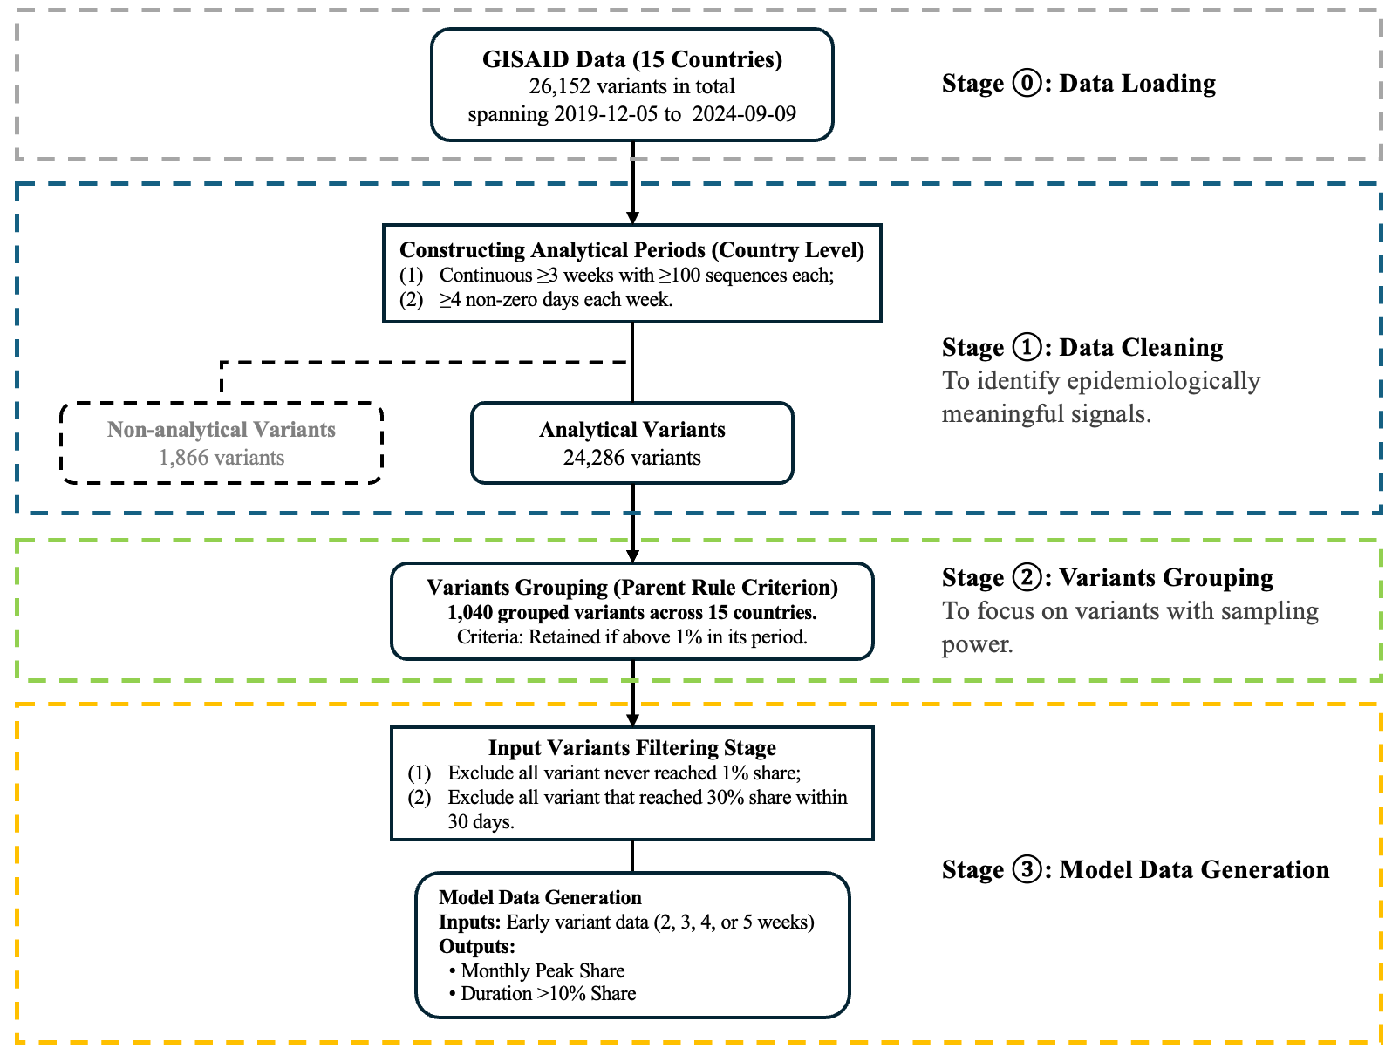
Figure 1. Overview of the data processing workflow, including data inclusion, exclusion, and grouping steps.

Stage 2: Analytic period---exclusion/inclusion variants
To maintain analytical relevance, we first segmented the global epidemic into six lineage-specific periods corresponding to the major VOC replacement timelines. Within each period, SARS-CoV-2 lineages were grouped into variants based on aggregated case proportions, retaining only those that exceeded a 1% share at any point. Across the six periods, this procedure yielded 1040 grouped variants, while all remaining lineages were pooled into the “others” category. This classification consolidates highly granular lineage data into a tractable number of epidemiologically meaningful groups. The grouping procedure was applied independently for each country to account for geographic heterogeneity in variant circulation. Figure 2 illustrates the evolving landscape of SARS-CoV-2 variants in the United States, the United Kingdom, and South Korea.

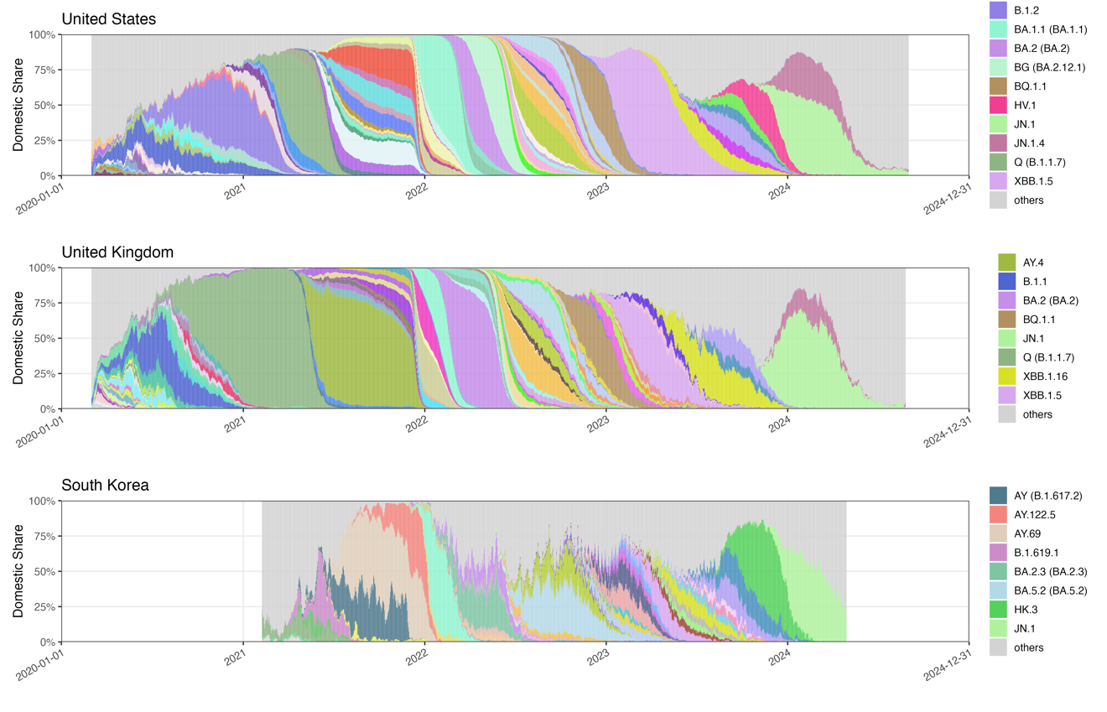
Figure 2. Time-series distribution of SARS-CoV-2 PANGO lineages during the analytical period in the United Kingdom, the United States, and South Korea. Only lineages with monthly maximum share > 30% and > 10% share sustained for > 100 days are shown in the legend.

Stage 3: Outcome definition-dominance and Input period and features
To quantify dominance, we defined the weekly maximum share (weekly peak) as the highest domestic share attained by a variant across any seven-day interval. Daily sequence counts were aggregated using a rolling seven-day window, within which the variant’s proportion was computed as its sequence count divided by the total sequences collected over the same window. The weekly peak was then taken as the maximum of these window-specific shares. This windowed formulation reduces sensitivity to day-level reporting noise while capturing the variant’s strongest observed competitive position. . This continuous measure, ranging from 0 to 1, captures the intensity of a variant’s competitive advantage. The distribution, however, is highly skewed, with most variants reaching only very small peaks (median ≈ 0.08, IQR: 0.03–0.20). To reduce the influence of extreme values and improve model stability, we transformed peak share into an ordered categorical variable with three levels: <10%, 10–20%, and >20%. This discretization produced a more balanced distribution across classes and enhanced the robustness of downstream modeling.

For variants predicted to exceed a 10% weekly share, the second outcome quantifies the duration of dominance, measured as the number of days the variant maintained a domestic share above 10%.. This measure focuses on periods of epidemiological relevance rather than the interval between first and last detection. Nearly one-third of the variants never exceeded the 10% threshold for more than 30 days. To address this heterogeneity and improve stability, the duration was grouped into three ordinal categories: 0–30, 31–100, and 100+ days. .

Weekly peak share and duration above a 10% threshold provide clearer measures of a variant’s competitive strength and epidemiological relevance than AUC alone, which can be inflated by long periods of low-level circulation. Unlike AUC, peak share highlights maximum competitive advantage and duration isolates sustained relevance, together avoiding misleading signals from variants with negligible impact.

To address these two questions, we employed a suite of machine learning approaches to fit predictive models. For predictor generation, the early stage of variant emergence was defined as a fixed observation window of 14, 21, 28, or 35 days, starting from the date when the variant first reached a 1% share in its respective country . Variants that never reached the 1% threshold were excluded from analysis. Consequently, the raw inputs consist of sequential share trajectories of length 14–35 days, depending on the selected observation window. To avoid confounding early predictors with signals of established dominance, we also excluded variants whose domestic share exceeded 30%—approximately the third quartile of the empirical distribution—within this initial period. Such variants were omitted from peak modeling because their trajectories already reflected high dominance. As a result, the number of variants retained for analysis varies slightly across early-stage definitions.

From these early share sequences, we then constructed two complementary sets of predictors. The first group comprised handcrafted, epidemiologically motivated predictors designed to capture basic growth dynamics. These included the overall log-linear slope (overall growth or decline rate), short-window slopes over seven days, the longest increasing run (consecutive growth days), and the non-zero count (number of days with non-zero share). All features were computed from the early stage share trajectories using base R functions and custom routines.

The second set was drawn from the catch22 library , accessed via the Rcatch22 package, which provides 22 minimally redundant descriptors of time-series structure such as entropy, fluctuation scaling, and motif frequency. The catch22 features are computationally efficient, robust to short and noisy sequences, and broadly applicable without parameter tuning—an important advantage given the heterogeneity of early trajectories. By combining interpretable, domain-informed measures with standardized machine-learning–oriented descriptors, this approach balances epidemiological interpretability with statistical power and enhances generalizability across diverse variant profiles.

Together, these features quantify each trajectory’s level, variability, early acceleration, and persistence, providing a rich basis for downstream prediction of peak share and time to dominance. We based our summary‐feature approach on established methods for extracting interpretable time‐series characteristics and on prior applications to SARS‐CoV-2 variant growth , yielding a compact set of metrics that capture level, variability, early acceleration, and persistence.

Analysis: Model fitting and assessments using machine learning methods
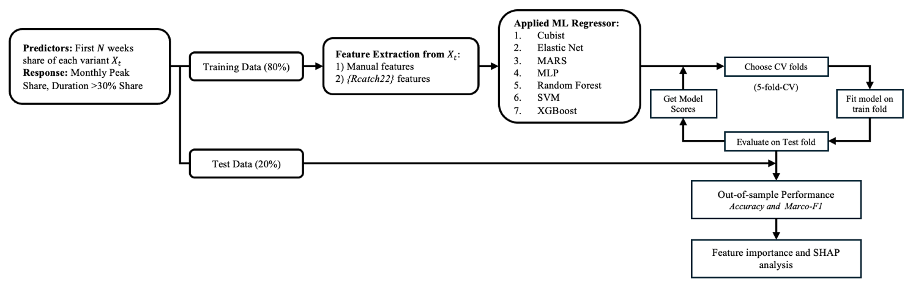
Figure 2. Modeling framework. Variant shares from the first N weeks were used to predict monthly peak share and duration above 10% share. Features included handcrafted and Rcatch22 descriptors.

Given our predictors—comprising handcrafted epidemiological features and statistical descriptors from the Rcatch22 library—and our two outcomes, a continuous monthly peak share and a categorical duration measure, we employed a diverse set of machine learning regressors suited for heterogeneous temporal data. These included generalized linear models , generalized additive models , regularized methods such as Elastic Net , kernel-based models , neural networks , and tree-based approaches . We further applied the SuperLearner R package , an ensemble learning framework that optimally combines multiple algorithms via cross-validated stacking. We applied a SuperLearner ensemble combining CART, GLM, and Elastic Net base learners to balance interpretability, flexibility, and regularization. This ensemble pools complementary models—CART for nonlinear patterns, GLM for main effects, and Elastic Net for correlated predictors—through cross-validated stacking to approximate the optimal weighted combination. By jointly leveraging information across countries or feature sets, the approach stabilizes variant fitness estimates and mitigates noise in data-sparse contexts.

Performance was assessed separately for the two outcomes to align evaluation with their statistical nature. For the continuous outcome of monthly peak, we used root mean squared error (RMSE) to measure average prediction error and the coefficient of determination (R²) to capture variance explained . For the categorical outcome of dominance duration, we reported overall accuracy and macro-F1, where accuracy summarizes the proportion of correct classifications and macro-F1 balances performance across imbalanced classes by averaging precision and recall equally . To further interpret model behavior, we applied variable importance analysis and SHAP decomposition , which together identify key predictors and quantify their contributions at both global and local levels. The entire workflow, from feature extraction to model fitting, evaluation, and interpretation, is summarized in Figure 2.
- Results
Country specific model performance.
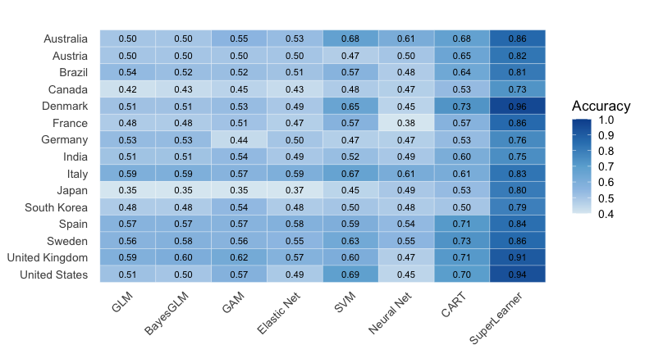
Figure 3(a). Heatmap of accuracy across models and countries for predicting monthly maximum share using a 21-day input. Blue = higher, white = lower.

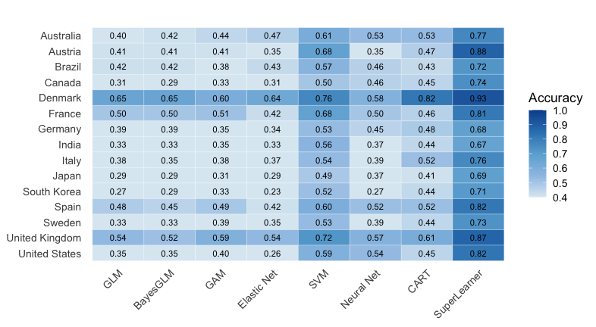
Figure 3(b). Heatmap of accuracy across models and countries for predicting maximum share using a 21-day input. Blue = higher, white = lower.

Figure 3(a) and 3(b) compare model accuracy for predicting variant dominance across 15 countries using 28-day and 21-day inputs, respectively. Across both input lengths, the SuperLearner ensemble consistently attains the highest accuracy, with notable gains in countries such as Denmark, France, the United Kingdom, and the United States. In contrast, individual models such as GLM, SVM, and CART show substantially lower accuracy, particularly in countries with noisier or sparser sequencing data. Overall, these results highlight the robustness of ensemble learning for forecasting monthly peak share, with performance advantages that persist across different input windows and national contexts.
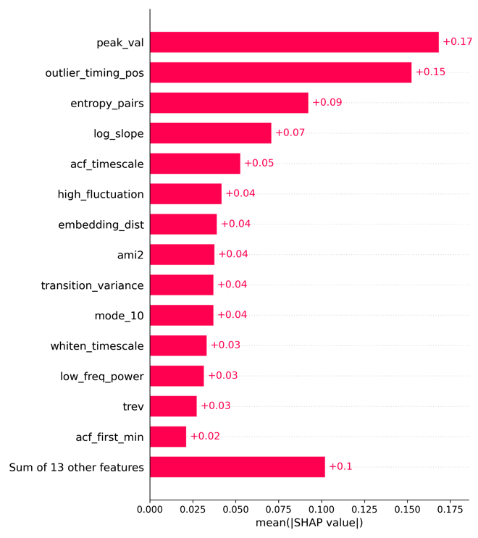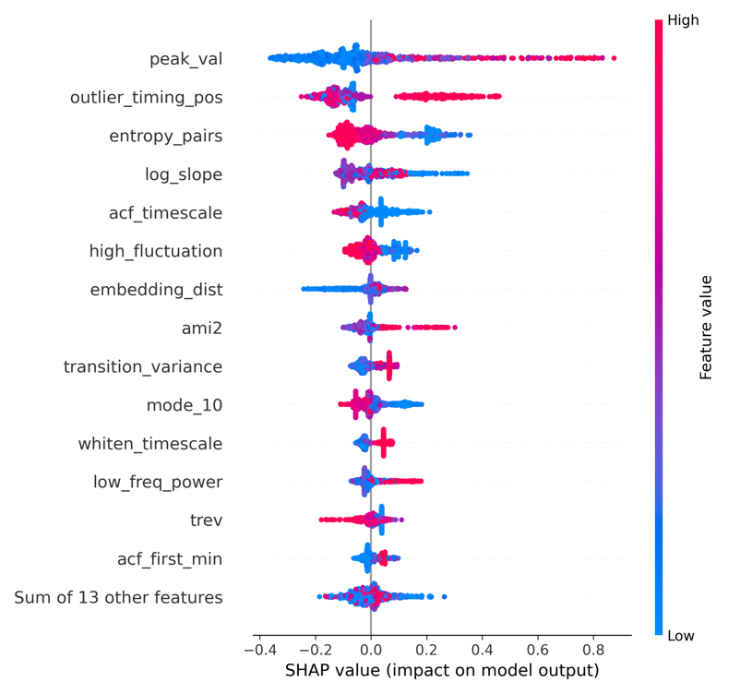

Figure 4 (a). SHAP values from the SuperLearner (21-day input) for predicting variant monthly peak share across 15 countries.

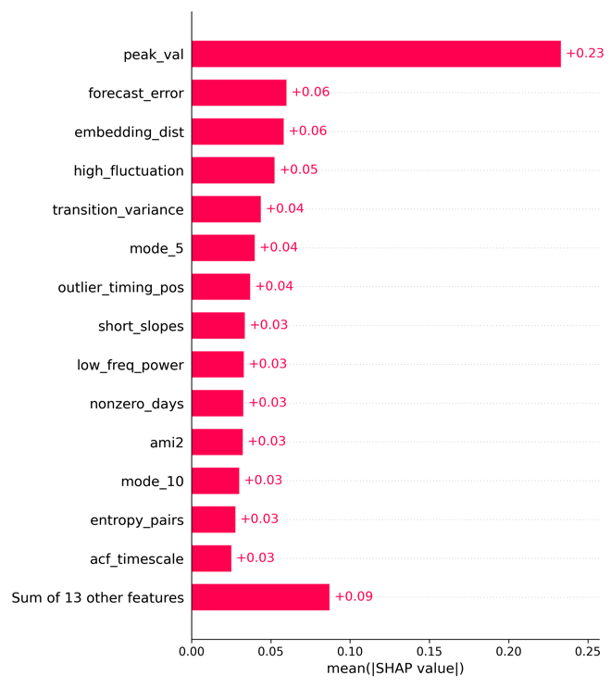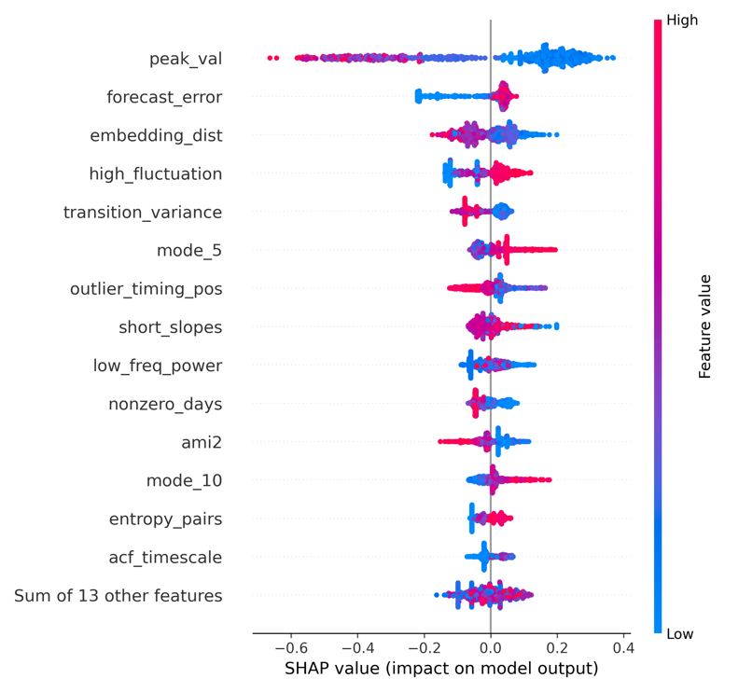
Figure 4 (b). SHAP values from the SuperLearner (21-day input) for predicting days above 10% share across 15 countries.

SHAP analysis
The SHAP analysis for the peak-share outcome (>20 percent) shows that both the magnitude and structural coherence of early growth are key determinants of whether a lineage reaches a high weekly peak (Figure 4a). The early maximum value (peak_val) exerts the strongest positive influence, indicating that lineages with substantial early expansion are most likely to achieve high peak prevalence. Later positive deviations (outlier_timing_pos) further reinforce this signal, while early isolated spikes tend to reduce predicted peaks, reflecting their interpretation as noise rather than evidence of sustained transmission. Structural characteristics of the trajectory refine these effects: higher entropy_pairs consistently lowers predictions, indicating that irregular symbolic patterns are not conducive to strong expansion, whereas longer autocorrelation timescales (acf_timescale) and moderate short-term fluctuation (high_fluctuation) reflect more persistent and coherent growth. Measures of geometric and nonlinear structure, including embedding_dist and ami2, similarly distinguish lineages whose early trajectories are organized and dynamically consistent. Overall, variants that combine strong early amplification with stable and structurally coherent growth are more likely to achieve high peak share.

The SHAP analysis for dominance duration (>100 days) reveals a distinct pattern from the peak-share outcome (Figure 4b). Early sharp peaks, reflected in peak_val, reduce predicted duration, indicating that rapid initial surges are characteristic of short-lived waves rather than sustained circulation. In contrast, greater short-horizon forecast variability (forecast_error) and stronger incremental day-to-day fluctuations (high_fluctuation) contribute positively, suggesting that lineages exhibiting recurrent, moderate short-term variation—rather than a single early spike—are more likely to persist. Higher embedding_dist and elevated transition_variance reduce predicted duration, implying that geometric irregularity and unstable state-switching signal transient rather than resilient growth. Overall, prolonged dominance appears to arise not from explosive early expansion but from continued small-scale dynamism embedded within a coherent and structurally stable growth trajectory.

Comparison of model prediction and observed dominant variants

Country | Lineage | Onset date | Offset date | Pred. Peak | Obs. Peak | Peak. Diff | Pred. Dur. | Obs. Dur. | Dur. Acc.
United States | B.1.2 | 2020-03-09 | 2023-07-17 | 0.10–0.20 | >0.20 | F | 31–100 | 100+ | F
 | Q (B.1.1.7) | 2020-03-12 | 2024-03-04 | 0.10–0.20 | >0.20 | F | 31–100 | 100+ | F
 | BA.2 (BA.2) | 2020-04-03 | 2024-08-22 | >0.20 | >0.20 | T | 100+ | 100+ | T
 | XBB.1.5 | 2020-04-04 | 2024-07-16 | >0.20 | >0.20 | T | 100+ | 100+ | T
 | AY.103 | 2020-05-14 | 2023-02-01 | >0.20 | >0.20 | T | 100+ | 100+ | T
 | BG (BA.2.12.1) | 2020-08-18 | 2024-08-28 | >0.20 | >0.20 | T | 100+ | 100+ | T
 | BF (BA.5.2.1) | 2021-11-05 | 2024-04-11 | >0.20 | >0.20 | T | 100+ | 100+ | T
 | BQ.1.1 | 2021-11-30 | 2024-03-27 | >0.20 | >0.20 | T | 100+ | 100+ | T
 | HV.1 | 2023-01-09 | 2024-08-16 | >0.20 | >0.20 | T | 100+ | 100+ | T
 | JN.1 | 2023-01-09 | 2024-08-31 | >0.20 | >0.20 | T | 100+ | 100+ | T
 | JN.1.4 | 2023-09-13 | 2024-08-29 | >0.20 | >0.20 | T | 100+ | 100+ | T
 | others (n = 68) | 2020-03-02 | 2024-08-16 | - | - | - | - | - | -
United Kingdom | B.1.1 | 2020-03-02 | 2022-06-23 | 0.10–0.20 | >0.20 | F | 31–100 | 100+ | F
 | Q (B.1.1.7) | 2020-03-03 | 2022-03-03 | 0.10–0.20 | >0.20 | F | 100+ | 100+ | T
 | BA.2 (BA.2) | 2021-01-01 | 2024-01-13 | >0.20 | >0.20 | T | 100+ | 100+ | T
 | BA.5.1 (BA.5.1) | 2022-01-12 | 2024-05-10 | >0.20 | >0.20 | T | 100+ | 100+ | T
 | BA.5.2 (BA.5.2) | 2022-01-17 | 2024-02-12 | >0.20 | >0.20 | T | 100+ | 100+ | T
 | BQ.1.1 | 2022-02-11 | 2024-01-01 | >0.20 | >0.20 | T | 100+ | 100+ | T
 | XBB.1.5 | 2022-10-30 | 2024-05-28 | 0.10–0.20 | >0.20 | F | 100+ | 100+ | T
 | XBB.1.16 | 2023-01-01 | 2024-04-17 | >0.20 | >0.20 | T | 100+ | 100+ | T
 | JN.1.4 | 2023-09-18 | 2024-08-25 | >0.20 | >0.20 | T | 100+ | 100+ | T
 | JN.1 | 2023-09-21 | 2024-08-24 | >0.20 | >0.20 | T | 100+ | 100+ | T
 | others (n = 76) | 2020-03-02 | 2024-07-10 | - | - | - | - | - | -
South Korea | B.1.619.1 | 2021-02-22 | 2021-09-21 | >0.20 | >0.20 | T | 100+ | 100+ | T
 | AY (B.1.617.2) | 2021-04-22 | 2023-07-11 | 0.10–0.20 | >0.20 | F | 100+ | 100+ | T
 | AY.69 | 2021-05-15 | 2022-02-10 | 0.10–0.20 | >0.20 | F | 100+ | 100+ | T
 | AY.122.5 | 2021-08-08 | 2022-03-04 | 0.10–0.20 | >0.20 | F | 100+ | 100+ | T
 | BA.2.3 (BA.2.3) | 2021-12-29 | 2023-03-15 | >0.20 | >0.20 | T | 100+ | 100+ | T
 | BF (BA.5.2.1) | 2022-05-10 | 2023-04-15 | 0.10–0.20 | >0.20 | F | 31–100 | 100+ | F
 | BA.5.2 (BA.5.2) | 2022-05-11 | 2024-01-22 | >0.20 | >0.20 | T | 100+ | 100+ | T
 | XBB.1.5 | 2022-11-23 | 2023-12-11 | 0.10–0.20 | >0.20 | F | 100+ | 100+ | T
 | EG.5.1.1 | 2023-05-16 | 2024-03-27 | 0.10–0.20 | >0.20 | F | 100+ | 100+ | T
 | HK.3 | 2023-07-04 | 2024-04-15 | >0.20 | >0.20 | T | 100+ | 100+ | T
 | JN.1 | 2023-10-24 | 2024-04-28 | 0.10–0.20 | >0.20 | F | 31–100 | 100+ | F
 | others (n = 37) | 2021-02-08 | 2024-02-20 | - | - | - | - | - | -
Table 3. Comparison of observed and predicted variant dominance in selected countries, defined as duration ≥100 days and peak >20%.

Table 3 summarizes model performance for the three most well-sampled countries under the operational definition of dominance (peak >20% and duration ≥100 days). In both the United States and the United Kingdom, the model showed strong consistency: nearly all major lineages—including BA.2, BA.5 sublineages, BQ.1.1, XBB.1.5, and JN.1—were correctly classified for both peak and duration, with only early variants (e.g., B.1.2 in the U.S., B.1.1 and B.1.1.7 in the U.K.) showing underestimation of peak magnitude. Results in South Korea were more heterogeneous: dominant variants were generally detected, but peak share was frequently underpredicted for Delta-related AY lineages and for later Omicron sublineages such as JN.1. Despite this, duration classification remained highly accurate across all three countries. Overall, the model achieves high agreement in the U.S. and U.K., with reduced peak-prediction stability in South Korea due to more variable early growth dynamics.

Discussion

This study shows that ensemble-based machine learning models can reliably forecast SARS-CoV-2 variant dominance using only 2–5 weeks of early growth information after initial emergence. By anchoring prediction windows to the point at which a lineage first exceeds 1 percent prevalence, the framework filters out noise from sporadic early detections and isolates the onset of sustained transmission. Across 15 countries, the SuperLearner—integrating CART, GLM, and Elastic Net—consistently achieves the highest accuracy and Macro-F1 scores for both peak-share and time-over-threshold outcomes across all early-input windows (Table S4). These results underscore the advantages of combining nonlinear, regularized, and interpretable learners into a unified ensemble for robust early forecasting.

The SHAP analysis highlights the specific early-growth patterns that differentiate lineages which later reach high peak share or sustain long-term dominance. For peak share, strong early expansion and coherent trajectory structure are the primary signals: higher early maxima, later positive deviations, longer autocorrelation timescales, and moderate short-term fluctuation all raise predicted peaks, while symbolic irregularity and geometric instability suppress them. In contrast, extended dominance is linked to a different configuration. Early sharp peaks reduce predicted duration, indicating that rapid initial surges tend to precede short-lived waves. Instead, lineages with recurrent short-horizon variability—captured by forecast_error and high_fluctuation—are more likely to persist, whereas geometric and transition-level instability (embedding_dist, transition_variance) reduce the likelihood of long-duration success. Together, these patterns show that sustained dominance arises not from explosive early growth but from early trajectories that combine stable structural organization with continued short-term dynamism.

In our framework, predictive uncertainty primarily stems from two intertwined sources: early growth and detection delay —which together shape the heterogeneity observed across countries . Variants exhibiting extremely rapid initial expansion compress both biological signal and stochastic noise into short time windows, making growth-related features (e.g., short-window slopes, fluctuation metrics) highly sensitive to sampling variability. In high-coverage settings such as Denmark or the United Kingdom, dense sequencing smooths these fluctuations and yields stable slope estimates; in contrast, sporadic sampling in countries like Brazil or South Korea amplifies volatility, occasionally misclassifying transient spikes as sustainable growth. Detection delays further compound these disparities by shifting each country’s analytical “Day 0” away from the true biological onset. In low-throughput systems, a variant may already be mid-growth when it first exceeds the 1 % threshold, leading to truncated or distorted early trajectories and underestimation of eventual dominance. This asymmetry explains why the model achieved near-perfect accuracy in data-rich settings but tended to underpredict peaks and durations in countries with limited sequencing continuity. Naïve growth-rate models struggle under these conditions, as a single spurious point or reporting lag can heavily bias slope estimates. Machine learning approaches are better suited because they integrate multiple features beyond simple growth rates, capture variability and persistence, and learn from diverse historical examples, making them more robust to noise and heterogeneity.

The mechanisms underlying variant dominance—and thus the sources of forecasting uncertainty and cross-country heterogeneity—shifted markedly over the course of the pandemic . During the early pandemic (2020–2021), when immunity was minimal, dominance was governed by viral transmissibility, resulting in globally synchronized peaks with relatively small variability—e.g., Alpha and Delta reached 80–95% prevalence in most countries (UK 98%, Germany 93%, Japan 93%, Spain 92%) with peak errors typically <20%. In contrast, the later period (2022–2024), dominated by Omicron sublineages, showed much greater heterogeneity: for BA.2, observed peaks ranged from 46% in Japan to 82% in Brazil (Δ ≈ 35%), and for JN.1, from 33% in Brazil to 79% in the UK (Δ > 45%). Correspondingly, peak prediction errors expanded to 30–40% in countries like France, Australia, and Brazil. These disparities emerged as immune escape became the principal determinant of variant success, with national immune landscapes—shaped by vaccination timing and prior infection history—causing divergent outcomes even among well-connected regions. Figgins and Bedford (2025) demonstrated that SARS-CoV-2 variant success transitioned from transmissibility-driven to immune-escape-driven dynamics as global immunity accumulated. Using genomic frequency data, they quantified time-varying fitness and selective pressure, showing that shifts in population immunity, rather than fixed viral traits, explain changing epidemic growth patterns across countries. Their latent immunity model accurately recapitulated human serological relationships, revealing that immune structure strongly predicts geographic differences in variant fitness.

Recent work by Abousamra et al. provides similar empirical support for the predictive value of fitness-based and frequency-growth models, demonstrating that relatively simple statistical models—such as multinomial logistic regression (MLR), fixed-growth advantage (FGA), and growth-advantage random walk (GARW)—can achieve median absolute errors below 2 % and mean errors of 6–12 % in 30-day forecasts under robust sequencing coverage, underscoring that the key limitation is data quality and timeliness, not model complexity. Their results confirm that variant-frequency trajectories contain sufficient early-stage information to anticipate near-term dominance, aligning closely with our finding that early growth signatures within the first 2–5 weeks are highly informative for forecasting both peak prevalence and persistence. Importantly, Abousamra et al. highlight that forecast accuracy deteriorates sharply in settings with sparse or delayed genomic surveillance, where submission lag and low weekly sequencing (< 50–100 samples) inflate forecast error to >10 %, suggesting roughly 1,000 sequences per week suffice for robust short-term forecasting. Together, these findings reinforce that predictive accuracy is bounded less by algorithmic sophistication than by timely, high-volume genomic data and adaptive calibration.
In this respect, a major contribution of our study is its comprehensive cross-country comparison of how dominant variants evolved across distinct pandemic phases, revealing how the drivers of dominance and uncertainty shifted over time. Given these dynamics, our study provides practical guidance on the minimum sequencing requirements and surveillance protocols (e.g. maintaining ≥100 sequences in the previous 30 days with ≥1% share detection threshold) needed to reduce early noise and improve the reliability of variant forecasting. The analysis demonstrates a scalable, data-driven framework for early-stage prediction of SARS-CoV-2 variant dominance using sequence-derived time-series features alone can achieve high forecasting performance by incorporaintg early-stage sequence-derived temporal features—particularly growth slopes, temporal entropy, and fluctuation dynamics—including linear, kernel-based, and ensemble methods across diverse epidemiological contexts. Using multi-country data, we also established a systematic approach for defining the initial observation phase, which minimizes early-stage noise, enhances detection of early growth signals, and ensures comparability of forecasting results across diverse surveillance settings.

This study has several methodological and data-related limitations that warrant consideration. First, although the analytical window was anchored to the first observation of a 1% variant share to mitigate stochastic noise in the earliest detections, this design inevitably truncates part of the emergence phase for variants with very low eventual prevalence. Consequently, such lineages may lose subtle but informative early dynamics, limiting the model’s ability to fully characterize weakly competitive or self-limiting variants. Second, while pooling data from 15 countries enhanced statistical power and allowed for a robust cross-national framework, it may also have introduced sampling bias toward countries with dense, continuous sequencing efforts (e.g., the United States, Denmark, and the United Kingdom), potentially underrepresenting signals from regions with sparser genomic surveillance. Third, like many other ML models, our model shows high predicton, but not mechanistic insights. PyR₀ model is one of the most influential frameworks for connecting molecular evolution to population-level variant dynamics, using a hierarchical Bayesian multinomial logistic regression model. It essentially decomposes lineage growth into mutation-level contributions to viral fitness. This means it can infer which individual amino acid changes are associated with faster spread, independent of geography or time. PyR₀ performs best once a variant reach ≥ 1% global frequency (roughly corresponding to 100–500 sequences in multiple countries ≥3 consecutive weeks). It also requires substantial computing power and data pre-processing pipelines, which limit its rapid application to low-sequencing countries. It also assumes each mutation’s effect is static across space and time, which may not hold under changing immunity landscapes or intervention policies. Finally, cross-country heterogeneity in model performance likely reflects structural differences in sequencing intensity, coverage, data continuity, reporting lags, as well as variation in public health interventions and epidemic baselines—factors that mediate how early growth signals translate into eventual dominance. On average, variants required about four months (116 days) to reach their national peak after first surpassing the 1% threshold, with the longest interval observed in Italy (206 days) and the shortest in Denmark (72 days). In contrast, our model relies on only two to five weeks of early data to generate forecasts—capturing signals long before the peak occurs. This substantial gap highlights the model’s practical value as an early-warning tool, capable of anticipating dominant trajectories well ahead of observed epidemic surges. Future studies could incorporate hierarchical or region-weighted model extensions that account for sampling bias (country-specific detection delays, surveillance cadence) and evolving immunity landscapes , which drive much of the cross-country heterogeneity in forecasting performance. Such enhancements would further improve model generalizability and robustness to uneven data quality, supporting the development of lightweight, scalable early-warning systems for global genomic surveillance. Pandemic preparedness will require multi-strategic AI frameworks combining genomic, immunological, and host data to anticipate immune escape, guide vaccine updates, and strengthen early-warning systems—while ensuring ethical governance to mitigate dual-use biosecurity risks .

Conclusion

This study presents a scalable, sequence-based framework for forecasting SARS-CoV-2 variant dominance using only early genomic growth information. Anchored to the 1% detection threshold, the model integrates handcrafted epidemiological features and standardized time-series descriptors to capture the critical onset of sustained transmission. The SuperLearner ensemble—combining CART, GLM, and Elastic Net—substantially outperformed individual models, reducing RMSE for peak prediction to 0.08 (≈60% improvement) and achieving 96% accuracy and 0.98 macro-F1 for duration classification across 15 countries. On average, variants required about four months to reach their national peak, whereas our framework achieved accurate predictions using only 2–5 weeks of early data, underscoring its value as an efficient early-warning system capable of anticipating variant trajectories well before peak dominance.

Beyond predictive performance, this work establishes standardized surveillance thresholds (≥100 sequences within 30 days, ≥1% detection share), variant-grouping and noise-filtering protocols, and cross-country comparability criteria that together ensure robustness under heterogeneous sequencing conditions. These design principles yield a lightweight, reproducible, and globally scalable framework for real-time genomic surveillance. More broadly, the approach provides a blueprint for adaptive epidemic intelligence systems that can operate effectively in both high- and low-resource settings, enabling early detection of emerging variants and supporting proactive public health responses.

References

Abousamra, Eslam, Marlin Figgins, and Trevor Bedford. “Fitness Models Provide Accurate Short-Term Forecasts of SARS-CoV-2 Variant Frequency.” PLOS Computational Biology 20, no. 9 (2024): e1012443. https://doi.org/10.1371/journal.pcbi.1012443.
Alberti, Tommaso, and Davide Faranda. “On the Uncertainty of Real-Time Predictions of Epidemic Growths: A COVID-19 Case Study for China and Italy.” Communications in Nonlinear Science & Numerical Simulation 90 (November 2020): 105372. https://doi.org/10.1016/j.cnsns.2020.105372.
Breiman, Leo, Jerome Friedman, R. A. Olshen, and Charles J. Stone. Classification and Regression Trees. Chapman and Hall/CRC, 2017. https://doi.org/10.1201/9781315139470.
Brito, Anderson F., Elizaveta Semenova, Gytis Dudas, et al. “Global Disparities in SARS-CoV-2 Genomic Surveillance.” Nature Communications 13, no. 1 (2022): 7003. https://doi.org/10.1038/s41467-022-33713-y.
CDC. “CDC’s Role in Tracking Variants.” COVID-19, September 5, 2025. https://www.cdc.gov/covid/php/variants/index.html.
CDC. “Variants and Genomic Surveillance.” COVID-19, August 28, 2025. https://www.cdc.gov/covid/php/variants/variants-and-genomic-surveillance.html.
Charniga, Kelly, Sang Woo Park, Andrei R. Akhmetzhanov, et al. “Best Practices for Estimating and Reporting Epidemiological Delay Distributions of Infectious Diseases.” PLOS Computational Biology 20, no. 10 (2024): e1012520. https://doi.org/10.1371/journal.pcbi.1012520.
Chen, Chaoran, Sarah Nadeau, Michael Yared, et al. “CoV-Spectrum: Analysis of Globally Shared SARS-CoV-2 Data to Identify and Characterize New Variants.” Bioinformatics (Oxford, England) 38, no. 6 (2022): 1735–37. https://doi.org/10.1093/bioinformatics/btab856.
Chowell, Gerardo, and Pavel Skums. “Investigating and Forecasting Infectious Disease Dynamics Using Epidemiological and Molecular Surveillance Data.” Physics of Life Reviews 51 (December 2024): 294–327. https://doi.org/10.1016/j.plrev.2024.10.011.
Cortes, Corinna, and Vladimir Vapnik. “Support-Vector Networks.” Machine Learning 20, no. 3 (1995): 273–97. https://doi.org/10.1007/BF00994018.
Figgins, Marlin D., and Trevor Bedford. “Frequency Dynamics Predict Viral Fitness, Antigenic Relationships and Epidemic Growth.” Preprint, medRxiv, September 12, 2025. https://doi.org/10.1101/2024.12.02.24318334.
Fulcher, Ben D., Max A. Little, and Nick S. Jones. “Highly Comparative Time-Series Analysis: The Empirical Structure of Time Series and Their Methods.” Journal of The Royal Society Interface 10, no. 83 (2013): 20130048. https://doi.org/10.1098/rsif.2013.0048.
“Generalized Linear Models on JSTOR.” Accessed October 20, 2025. https://www.jstor.org/stable/2344614?seq=1.
GISAID. “GISAID.” n.d. https://doi.org/10.55876/gis8.220330me.
Hamelin, D. J., M. Scicluna, I. Saadie, et al. “Predicting Pathogen Evolution and Immune Evasion in the Age of Artificial Intelligence.” Computational and Structural Biotechnology Journal 27 (January 2025): 1370–82. https://doi.org/10.1016/j.csbj.2025.03.044.
Hamelin, D. J., M. Scicluna, I. Saadie, et al. “Predicting Pathogen Evolution and Immune Evasion in the Age of Artificial Intelligence.” Computational and Structural Biotechnology Journal 27 (January 2025): 1370–82. https://doi.org/10.1016/j.csbj.2025.03.044.
Harvey, William T., Alessandro M. Carabelli, Ben Jackson, et al. “SARS-CoV-2 Variants, Spike Mutations and Immune Escape.” Nature Reviews Microbiology 19, no. 7 (2021): 409–24. https://doi.org/10.1038/s41579-021-00573-0.
Hodcroft, Emma B., Moira Zuber, Sarah Nadeau, et al. “Spread of a SARS-CoV-2 Variant through Europe in the Summer of 2020.” Nature 595, no. 7869 (2021): 707–12. https://doi.org/10.1038/s41586-021-03677-y.
James, Gareth, Daniela Witten, Trevor Hastie, and Robert Tibshirani. An Introduction to Statistical Learning: With Applications in R. Springer Texts in Statistics. Springer US, 2021. https://doi.org/10.1007/978-1-0716-1418-1.
Kraemer, Moritz U. G., Verity Hill, Christopher Ruis, et al. “Spatiotemporal Invasion Dynamics of SARS-CoV-2 Lineage B.1.1.7 Emergence.” Science 373, no. 6557 (2021): 889–95. https://doi.org/10.1126/science.abj0113.
Lubba, Carl H., Sarab S. Sethi, Philip Knaute, Simon R. Schultz, Ben D. Fulcher, and Nick S. Jones. “Catch22: CAnonical Time-Series CHaracteristics.” arXiv:1901.10200. Preprint, arXiv, January 30, 2019. https://doi.org/10.48550/arXiv.1901.10200.
Lundberg, Scott, and Su-In Lee. “A Unified Approach to Interpreting Model Predictions.” arXiv:1705.07874. Preprint, arXiv, November 25, 2017. https://doi.org/10.48550/arXiv.1705.07874.
Obermeyer, Fritz, Martin Jankowiak, Nikolaos Barkas, et al. “Analysis of 6.4 Million SARS-CoV-2 Genomes Identifies Mutations Associated with Fitness.” Science (New York, N.Y.) 376, no. 6599 (2022): 1327–32. https://doi.org/10.1126/science.abm1208.
Organization, World Health. SARS-CoV-2 Genomic Sequencing for Public Health Goals: Interim Guidance, 8 January 2021. WHO/2019-nCoV/genomic_sequencing/2021.1. World Health Organization, 2021, WHO/2019-nCoV/genomic_sequencing/2021.1. https://iris.who.int/handle/10665/338483.
Polley, Eric, and Mark van der Laan. “Super Learner In Prediction.” U.C. Berkeley Division of Biostatistics Working Paper Series, May 3, 2010. https://biostats.bepress.com/ucbbiostat/paper266.
Ripley, Brian D. Pattern Recognition and Neural Networks. Cambridge University Press, 1996. https://doi.org/10.1017/CBO9780511812651.
Sokolova, Marina, and Guy Lapalme. “A Systematic Analysis of Performance Measures for Classification Tasks.” Information Processing & Management 45, no. 4 (2009): 427–37. https://doi.org/10.1016/j.ipm.2009.03.002.
Susswein, Zachary, Kaitlyn E. Johnson, Robel Kassa, et al. “Leveraging Global Genomic Sequencing Data to Estimate Local Variant Dynamics.” Preprint, medRxiv, March 20, 2023. https://doi.org/10.1101/2023.01.02.23284123.
“Tracking SARS-CoV-2 Variants.” Accessed October 20, 2025. https://www.who.int/activities/tracking-SARS-CoV-2-variants.
“Tracking SARS-CoV-2 Variants.” Accessed July 16, 2025. https://www.who.int/activities/tracking-SARS-CoV-2-variants.
Volz, Erik, Swapnil Mishra, Meera Chand, et al. “Assessing Transmissibility of SARS-CoV-2 Lineage B.1.1.7 in England.” Nature 593, no. 7858 (2021): 266–69. https://doi.org/10.1038/s41586-021-03470-x.
Warton, David I., and Francis K. C. Hui. “The Arcsine Is Asinine: The Analysis of Proportions in Ecology.” Ecology 92, no. 1 (2011): 3–10. https://doi.org/10.1890/10-0340.1.
Wood, Simon N. Generalized Additive Models: An Introduction with R, Second Edition. 2nd ed. Chapman and Hall/CRC, 2017. https://doi.org/10.1201/9781315370279.
Zou, Hui, and Trevor Hastie. “Addendum: Regularization and Variable Selection Via the Elastic Net.” Journal of the Royal Statistical Society Series B: Statistical Methodology 67, no. 5 (2005): 768. https://doi.org/10.1111/j.1467-9868.2005.00527.x.

Appendix

This table extends Table 1 by providing year-by-year summaries of the raw Pango lineages sampled the rest 12 countries. It reports both the total number of cases available for genomic analysis and the five most prevalent lineages in each year.

Country | Year | Number of Cases | Top Five PANGO Lineages (Annual Proportional Share)
United States | 2020 | 18,903,169 | B.1 (1.1%); B.1.1 (1.1%); B.1.595 (1.1%); B.1.369 (1.1%); B.1.243 (1%)
 | 2021 | 196,861,939 | B.1 (1.0%); B.1.617.2 (1%); AY.44 (0.9%); B (0.9%); AY.25 (0.9%)
 | 2022 | 227,680,907 | BA.2 (0.7%); BA.1.1 (0.6%); BA.2.12.1 (0.6%); BA.2.3 (0.6%); BA.2.9 (0.5%)
 | 2023 | 71,328,981 | XBB.1.5 (0.5%); XBB.1.5.10 (0.4%); XBB.1 (0.4%); XBB.1.5.15 (0.4%); XBB.1.5.49 (0.4%)
 | 2024 | 9,457,427 | JN.1 (1.1%); JN.1.8 (1.1%); JN.1.18 (1%); JN.1.7 (1%); JN.1.4 (1.0%)
United Kingdom | 2020 | 13,728,198 | B.1.1 (1.2%); B.1 (1.2%); B.1.1.37 (1%); B.1.1.1 (1%); B.1.177 (0.9%)
 | 2021 | 84,393,505 | AY.4 (1.5%); B.1.617.2 (1.5%); AY.122 (1.5%); AY.5 (1.5%); AY.111 (1.5%)
 | 2022 | 79,974,012 | BA.2 (1.3%); BA.2.3 (1.2%); BA.1.1 (1.2%); BA.2.10 (1.2%); BA.1 (1.2%)
 | 2023 | 8,416,483 | XBB.1.5 (0.9%); XBB.1.9.1 (0.7%); CH.1.1.1 (0.7%); XBB.1.5.7 (0.7%); XBB.1.5.18 (0.7%)
 | 2024 | 934,727 | JN.1 (2%); JN.1.7 (1.9%); KP.2 (1.7%); KP.3 (1.6%); JN.1.8 (1.5%)
Germany | 2020 | 108,912 | B.1.1 (7.3%); B.1 (6.5%); B.1.258 (3.7%); B.1.177 (3.6%); B.1.160 (3.4%)
 | 2021 | 20,390,838 | B.1.617.2 (1.4%); AY.122 (1.3%); AY.4 (1.1%); AY.126 (1.1%); AY.9.2 (1.1%)
 | 2022 | 36,740,424 | BA.2 (1.3%); BA.2.9 (1.1%); BA.2.3 (1%); BA.2.65 (1%); BA.2.10 (0.9%)
 | 2023 | 6,236,183 | XBB.1.5 (0.7%); XBB.1 (0.7%); CH.1.1 (0.7%); BQ.1.1 (0.6%); XBB.1.5.46 (0.6%)
 | 2024 | 56,691 | JN.1 (6.5%); KP.3.3 (3.6%); KP.3.1.1 (3.4%); JN.1.16 (3.3%); JN.1.4 (2.9%)
Japan | 2020 | 134,325 | B.1.1.284 (14%); B.1.1.214 (13.8%); B.1.1 (8.5%); B.1.560 (4.3%); B.1 (4%)
 | 2021 | 2,034,956 | B.1.1.7 (7.8%); B.1.617.2 (6.8%); AY.29 (6%); AY.75.3 (5.3%); AY.29.1 (4.9%)
 | 2022 | 26,631,154 | BA.2.3 (1%); BA.2 (0.9%); BA.5.2.1 (0.9%); BA.5.1 (0.9%); BA.5.2 (0.9%)
 | 2023 | 9,390,301 | XBB.1.5 (0.8%); BF.7.15 (0.6%); BN.1.2 (0.6%); BN.1.2.2 (0.6%); BF.7.4.1 (0.6%)
 | 2024 | 646,792 | XDQ.1 (2.3%); JN.1 (2.2%); XDQ (2.1%); JN.1.4 (2.1%); BA.2.86.1 (2%)
Denmark | 2020 | 2,278,524 | B.1.1 (1.5%); B.1 (1.5%); B.1.1.298 (1.5%); B.1.160 (1.5%); B.1.1.277 (1.4%)
 | 2021 | 11,304,092 | B.1.617.2 (1.9%); AY.122 (1.7%); AY.4 (1.7%); AY.46 (1.6%); AY.43 (1.5%)
 | 2022 | 17,001,863 | BA.2 (1.7%); BA.2.9 (1.6%); BA.2.3 (1.3%); BA.2.65 (1.3%); BA.1.1 (1.3%)
 | 2023 | 1,581,532 | XBB.1.5 (1%); CH.1.1.12 (0.8%); CH.1.1 (0.8%); XBB.1 (0.8%); BQ.1.1 (0.7%)
 | 2024 | 77,590 | JN.1.20 (2.6%); KP.2 (2.3%); KP.3.1 (2.3%); KP.3.3 (2.3%); KP.3 (2.3%)
Canada | 2020 | 584,489 | B.1.1.176 (3.9%); B.1.1 (3.8%); B.1 (3.5%); B.1.279 (3.5%); B.1.128 (3.3%)
 | 2021 | 6,797,225 | B.1.617.2 (2.4%); AY.27 (2.2%); AY.74 (2%); B.1.1.7 (2%); AY.122 (1.9%)
 | 2022 | 12,176,039 | BA.2 (1.1%); BA.2.3 (1%); BA.2.12.1 (1%); BA.5.1 (0.9%); BA.1.1 (0.9%)
 | 2023 | 8,189,558 | XBB.1.5 (1.1%); XBB.1.16 (0.8%); EG.5.1.1 (0.7%); XBB.1.16.6 (0.6%); EG.5.1 (0.6%)
 | 2024 | 1,374,129 | KP.2 (1.7%); KP.3 (1.7%); JN.1.4 (1.7%); JN.1 (1.7%); JN.1.7 (1.6%)
France | 2020 | 79,452 | B.1 (8.7%); B.1.1 (6.6%); B.1.160 (6.4%); B.1.177 (6%); B.1.1.269 (4%)
 | 2021 | 12,230,918 | B.1.617.2 (1.5%); AY.122 (1.4%); AY.43 (1.4%); AY.5 (1.4%); AY.4 (1.4%)
 | 2022 | 22,865,501 | BA.2 (1.1%); BA.2.9 (0.9%); BA.2.3 (0.8%); BA.1.18 (0.8%); BA.1.1 (0.8%)
 | 2023 | 5,633,065 | XBB.1.5 (0.7%); XBB.1.9.1 (0.6%); XBB.1.16 (0.6%); XBB.2.3 (0.5%); XBB.1.17.1 (0.5%)
 | 2024 | 313,992 | KP.3.1.1 (1.8%); KP.3.1 (1.7%); KP.2.2 (1.6%); KP.2.3 (1.6%); KP.3 (1.6%)
Sweden | 2020 | 17,246 | B.1.1 (12.7%); B.1 (11.4%); B.1.177 (5.4%); B.1.160 (5.3%); B.1.177.82 (4.4%)
 | 2021 | 3,920,346 | B.1.1.7 (2.5%); B.1.617.2 (2.1%); B.1.351 (2.1%); AY.122 (1.8%); AY.4 (1.6%)
 | 2022 | 3,592,183 | BA.2 (1.7%); BA.2.9 (1.5%); BA.2.65 (1.4%); BA.5.2.1 (1.2%); BA.5.1 (1.2%)
 | 2023 | 1,136,251 | XBB.1.5 (1.3%); EG.5.1.1 (1.1%); EG.5.1.3 (1%); HK.3 (1%); JN.2 (1%)
 | 2024 | 51,081 | JN.1.16 (3.8%); KP.3.1 (3.5%); JN.1 (3.1%); KP.3.1.1 (3.1%); JN.1.4 (2.7%)
Spain | 2020 | 89,756 | B.1 (11.2%); B.1.177 (8.2%); B.1.1 (8.1%); A.2 (4.9%); A.5 (4.6%)
 | 2021 | 2,937,437 | B.1.617.2 (2.6%); B.1.1.7 (2.4%); AY.43 (2.3%); AY.42 (2.3%); AY.122 (2.2%)
 | 2022 | 3,185,817 | BA.2 (2.5%); BA.2.9 (2%); BA.5.1 (1.7%); BA.2.3 (1.6%); BA.1.1 (1.5%)
 | 2023 | 1,836,994 | XBB.1.5 (1.7%); XBB.2.3 (1.3%); XBB.1.16 (1.1%); XBB.1.9.1 (1.1%); DV.7.1 (1.1%)
 | 2024 | 497,323 | JN.1 (3.2%); JN.1.11 (2.3%); KP.3.1.1 (2.3%); KP.3.1 (2.2%); JN.1.32 (2.2%)
Brazil | 2020 | 57,230 | B.1.1.28 (17.8%); B.1.1.33 (17.5%); B.1.1 (14.2%); P.2 (8.7%); B.1 (5.7%)
 | 2021 | 2,217,203 | P.1 (4.4%); P.1.7 (3.7%); AY.101 (3.5%); AY.99.2 (3.5%); P.1.14 (3.4%)
 | 2022 | 2,364,004 | BA.2 (2.9%); BA.1.1 (2.6%); BA.1 (2.5%); BA.1.14.1 (2.2%); BA.5.2.1 (2.1%)
 | 2023 | 282,318 | XBB.1.5 (4%); GK.1 (3.6%); XBB.1.5.70 (3.3%); FE.1.2 (3.2%); XBB.1.18.1 (3.1%)
 | 2024 | 71,855 | JN.1 (5.9%); XDR (5.7%); JN.1.43.1 (5.5%); JN.1.1 (5.3%); JN.1.29 (5.1%)
Australia | 2020 | 112,834 | D.2 (11.6%); D.3 (7.9%); B.1 (5.3%); B.1.1 (3.9%); B (2.8%)
 | 2021 | 329,681 | AY.39.1 (10.6%); AY.39.1.2 (9.8%); AY.39 (9.7%); AY.39.1.3 (8%); AY.39.1.4 (6%)
 | 2022 | 4,957,284 | BA.2 (1.6%); BA.5.2.1 (1.3%); BA.2.3 (1.3%); BA.5.2 (1.3%); BA.5.1 (1.2%)
 | 2023 | 1,962,178 | XBC.1.6 (1.5%); XBB.1.5 (1.4%); XBC.1.3 (1.3%); XBF (1.2%); EG.1 (1.2%)
 | 2024 | 189,619 | JN.1 (3.3%); KP.3 (3.1%); JN.1.32 (2.9%); KW.1 (2.8%); KW.1.1 (2.8%)
South Korea | 2020 | 5,878 | B.1.497 (37.3%); B.1 (9.8%); B.1.1 (8.0%); B.41 (2.9%); A (2.8%)
 | 2021 | 215,082 | AY.69 (11.6%); B.1.617.2 (11.6%); AY.122 (9.4%); AY.122.5 (8.0%); B.1.619.1 (6.4%)
 | 2022 | 2,827,981 | BA.5.2 (2.0%); BA.5.2.1 (2.0%); BA.5.1 (1.8%); BA.2.3 (1.8%); BA.2 (1.7%)
 | 2023 | 4,438,592 | XBB.1.5 (1.2%); XBB.1.16 (1.0%); EG.1.6 (1.0%); EG.1 (1.0%); XBB.1.9.1 (1.0%)
 | 2024 | 225,726 | JN.1.4 (4.2%); JN.1 (4.1%); JN.1.20 (3.9%); JN.1.4.5 (3.8%); JN.1.5 (3.4%)
India | 2020 | 110,087 | B.1 (8.4%); B.1.36 (8.3%); B.1.1.306 (8.3%); B.1.36.8 (6.2%); B.1.1 (6%)
 | 2021 | 1,828,869 | B.1.617.2 (5.2%); AY.122 (4.8%); AY.112 (4.4%); AY.127 (4.3%); AY.120 (4.2%)
 | 2022 | 1,993,683 | BA.2 (3.5%); BA.2.10 (3.2%); BA.2.10.1 (2.2%); BA.2.38 (2.2%); BA.1.1 (2%)
 | 2023 | 319,850 | XBB.2.3 (3.5%); XBB.1.16 (3.5%); XBB.1.16.1 (3.4%); XBB.1 (3.2%); XBB.2.3.2 (3.2%)
 | 2024 | 17,225 | JN.1.11 (7.8%); JN.1 (7.7%); KP.2 (5.8%); JN.1.1 (5.5%); JN.1.11.1 (4.7%)
Italy | 2020 | 46,856 | B.1 (7.7%); B.1.177 (7.2%); B.1.1 (6.5%); B.1.160 (5.5%); B.1.177.33 (5.2%)
 | 2021 | 2,405,500 | B.1.617.2 (2.7%); AY.122 (2.6%); B.1.1.7 (2.4%); AY.4 (2.2%); AY.43 (2.2%)
 | 2022 | 2,564,765 | BA.2 (2%); BA.1.1 (1.5%); BA.2.9 (1.5%); BA.5.1 (1.4%); BA.1 (1.3%)
 | 2023 | 821,001 | XBB.1.5 (1.8%); BQ.1.1 (1.2%); CH.1.1 (1.2%); XBB.1.9.1 (1%); BQ.1.1.47 (1%)
 | 2024 | 37,776 | JN.1 (4.9%); JN.1.11 (4.6%); KP.3.1.1 (4.2%); JN.1.16 (4.1%); JN.1.4 (3.5%)
Austria | 2020 | 13,291 | B.1 (10.4%); B.1.1 (10.3%); B.1.160 (6.5%); B.1.258 (6%); B.1.1.70 (4.4%)
 | 2021 | 223,390 | B.1.617.2 (7.8%); AY.43 (6.9%); AY.122 (6.9%); AY.4 (6.4%); AY.46.6 (4.9%)
 | 2022 | 5,359,174 | BA.2 (1.7%); BA.5.1 (1.6%); BA.5.2.1 (1.6%); BA.5.2 (1.6%); BA.5 (1.5%)
 | 2023 | 2,794,173 | XBB.1.5 (1.2%); CH.1.1 (1%); BQ.1.1 (1%); XBB.1.5.63 (0.9%); EG.1.2 (0.9%)
 | 2024 | 2,410 | JN.1 (12.8%); JN.1.4 (10.8%); JN.1.1 (6.9%); JN.1.4.5 (4.7%); HK.3 (4.6%)
Table S1: Descriptive summary of GASID data showing the distribution of raw PANGO lineages in all top 15 countries.

Data Processing
Figure S1 illustrates the analytical periods defined in Stage 1 of the data workflow, indicated by the two vertical blue lines. Within these boundaries, daily reported COVID-19 cases (black dots) are plotted to reflect the total denominators available for variant analysis. Across countries, the analytical periods are generally aligned to cover the major epidemic waves while excluding early sparse reporting and late low-case periods. For example, countries with sustained surveillance and larger case counts (e.g., United States, United Kingdom, Germany) have broader analytical windows, while countries with smaller denominators (e.g., Austria, Australia, South Korea) show narrower periods, ensuring that analysis is performed during intervals of reliable case volume.
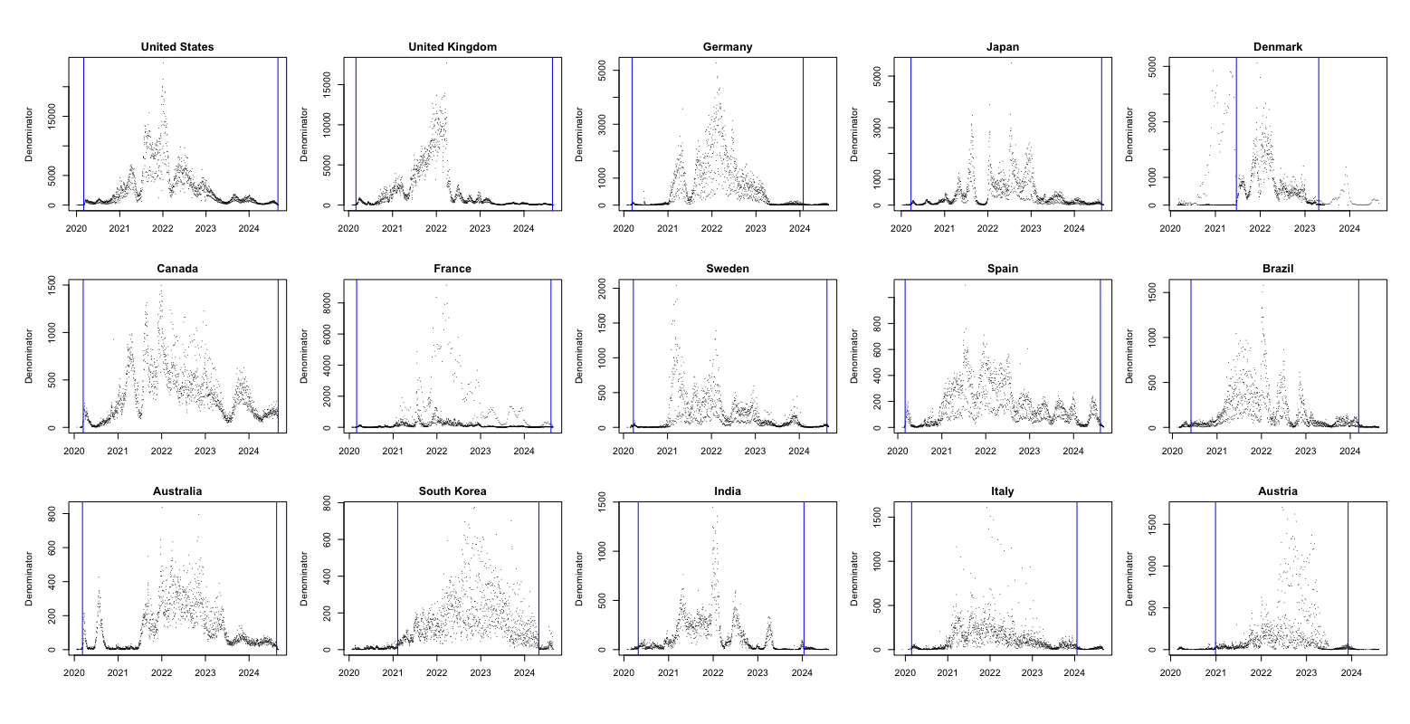
Figure S2: Analytical periods (blue vertical lines) defined for the 15 study countries, overlaid on their sequencing denominators across time.

These three panels illustrate the major SARS-CoV-2 variants from the United States (Figure S2a), the United Kingdom (Figure S2b), and South Korea (Figure S2c) that were excluded from the analytical period. For each country, the six variants with the largest overall sample volumes were selected for display. As shown, these variants either circulated primarily before the onset of the analytical period (e.g., B.1, B.1.1) or after its end (e.g., KP.3.1.1, JN.1.16), and thus fell outside the defined analytical scope. This corresponds to the earlier description of the analytical period: the dashed blue vertical lines mark the study window, and variants outside this interval were excluded.
Figure S3 (a): Main SARS-CoV-2 variants from the United States in the GISAID dataset that were excluded from the analytical scope.
Figure S3 (b): Main SARS-CoV-2 variants from the United Kingdom in the GISAID dataset that were excluded from the analytical scope.
Figure S2 (c): Main SARS-CoV-2 variants from the South Korea in the GISAID dataset that were excluded from the analytical scope.

Table S2 summarizes excluded variants across countries at different input windows (14–35 days), showing at which stage they failed to meet inclusion criteria. Variants were excluded either because they had already surpassed 30% share during the window or never reached 1%, with check marks indicating the reason for exclusion.

Country | Lineage | Exclusion Stage | Already Reached 30% | Never reach 1%
United States | AY.114 | 14 Days |  | ✓
United States | AY.120 | 14 Days |  | ✓
United States | AY.46.4 | 14 Days |  | ✓
United States | XBB | 14 Days |  | ✓
United Kingdom | AY.127 | 14 Days |  | ✓
United Kingdom | AY.36 | 14 Days |  | ✓
United Kingdom | AY.4.8 | 14 Days |  | ✓
United Kingdom | AY.9.2 | 14 Days |  | ✓
Germany | B.1 | 14 Days | ✓
Germany | B.1.258 | 14 Days | ✓
Japan | P4 (B.1.1.284) | 14 Days | ✓
Canada | B.1 | 14 Days | ✓
Canada | C57 (B.1.1.157) | 14 Days | ✓
Sweden | B.1.258 | 14 Days | ✓
Sweden | B.1.351 | 14 Days | ✓
Brazil | P (B.1.1.28) | 14 Days | ✓
Australia | AY.39.1 | 14 Days | ✓
Austria | Q (B.1.1.7) | 14 Days | ✓
India | B.1 | 14 Days | ✓
Denmark | BA.1 (BA.1) | 21 Days | ✓
Sweden | QB.1.177.82 (B.1.177.82) | 21 Days | ✓
Australia | B.1 | 21 Days | ✓
Australia | BA.1.17 (BA.1.17) | 21 Days | ✓
Brazil | BE.9 | 21 Days | ✓
Canada | B.1.279 | 28 Days | ✓
France | EG.5.1.3 | 28 Days | ✓
Italy | B.1 | 28 Days | ✓
Table S2: List of excluded variants in different number of input days modeling and the reason to be excluded.

Feature Extraction
These tables summarize the feature sets used in our analysis. Table S3(a) lists the six manually defined, epidemiologically motivated features that capture variant growth, prevalence, and sampling activity. Table S3(b) presents the catch22 feature set, which provides statistically motivated descriptors of time-series dynamics, including distributional, autocorrelation, spectral, nonlinear, and motif-based properties. Together, they ensure a balance between domain-driven interpretability and statistical richness.

# | Feature Name | Short Name | Category | Description
1 | Log-linear slope | log_slope | Growth trend | Growth or decline estimated
2 | Short-window slopes | short_slopes | Early growth | Slopes from first k days (e.g., 7 days)
3 | Longest increasing run | inc_run | Temporal dynamics | Longest sequence of strictly increasing values
4 | Non-zero count | nonzero_days | Sampling activity | Days with non-zero observed share
Table S3 (a): Manually defined epidemiological features used for modeling lineage time series.

# | Feature Name | Short Name | Category | Description
1 | DN_HistogramMode_5 | mode_5 | Distribution shape | 5-bin histogram mode
2 | DN_HistogramMode_10 | mode_10 | Distribution shape | 10-bin histogram mode
3 | DN_OutlierInclude_p_001_mdrmd | outlier_timing_pos | Extreme event timing | Positive outlier timing
4 | DN_OutlierInclude_n_001_mdrmd | outlier_timing_neg | Extreme event timing | Negative outlier timing
5 | first1e_acf_tau | acf_timescale | Linear autocorrelation | First 1/e crossing of the ACF
6 | firstMin_acf | acf_first_min | Linear autocorrelation | First minimum of the ACF
7 | SP_Summaries_welch_rect_area_5_1 | low_freq_power | Linear autocorrelation | Power in lowest 20% frequencies
8 | SP_Summaries_welch_rect_centroid | centroid_freq | Linear autocorrelation | Centroid frequency
9 | FC_LocalSimple_mean3_stderr | forecast_error | Simple forecasting | Error of 3-point rolling mean forecast
10 | FC_LocalSimple_mean1_tauresrat | whiten_timescale | Incremental differences | Change in autocorr. timescale after differencing
11 | MD_hrv_classic_pnn40 | high_fluctuation | Incremental differences | Proportion of high incremental changes
12 | SB_BinaryStats_mean_longstretch1 | stretch_high | Symbolic | Longest stretch of above-mean values
13 | SB_BinaryStats_diff_longstretch0 | stretch_decreasing | Symbolic | Longest stretch of decreasing values
14 | SB_MotifThree_quantile_hh | entropy_pairs | Symbolic | Entropy of successive pairs in symbolized series
15 | CO_HistogramAMI_even_2_5 | ami2 | Nonlinear autocorrelation | Histogram-based AMI (lag 2, 5 bins)
16 | CO_trev_1_num | trev | Nonlinear autocorrelation | Time reversibility
17 | IN_AutoMutualInfoStats_40_gaussian_fmmi | ami_timescale | Linear autocorrelation | First minimum of AMI function
18 | SB_TransitionMatrix_3ac_sumdiagcov | transition_variance | Symbolic | Transition matrix column variance
19 | PD_PeriodicityWang_th001 | periodicity | Linear autocorrelation | Wang's periodicity metric
20 | CO_Embed2_Dist_tau_d_expfit_meandiff | embedding_dist | Linear autocorrelation | Exponential fit to embedding dist. distribution
21 | SC_FluctAnal_2_rsrangefit_50_1_logi_prop_r1 | rs_range | Self-affine scaling | Rescaled range fluctuation analysis (low-scale)
22 | SC_FluctAnal_2_dfa_50_1_2_logi_prop_r1 | dfa | Self-affine scaling | Detrended fluctuation analysis (low-scale)
23 | DN_Mean | mean | Catch24 extension | Mean of raw series
24 | DN_Spread_Std | std | Catch24 extension | Standard deviation of raw series
Table S3 (b): Statistically motivated catch22 features (plus extensions), grouped by conceptual category.

Overall model performance based on 15 countries GISAID data.
For the prediction of monthly maximum share, the SuperLearner ensemble substantially outperformed all individual models, with RMSE improving from 0.12 at 14 days to 0.08 at 28 days and R² increasing from 0.63 to 0.80. This represents a marked improvement over the best single model (CART, RMSE = 0.16, R² = 0.25), demonstrating the ensemble’s ability to combine linear, tree-based, and regularized learners to capture nonlinear yet smooth variant growth trajectories. Performance gains were consistent as the observation window lengthened, indicating that longer early-stage inputs provide clearer signals of future peak dominance.

For predicting duration above 10% share, the SuperLearner again achieved the highest performance, with accuracy rising from 0.88 at 14 days to 0.98 at 35 days and macro-F1 increasing from 0.87 to 0.98. While single models such as SVM and CART performed moderately well (accuracy ≈ 0.65–0.70), the ensemble’s gains were substantial, reflecting its robustness in modeling categorical outcomes with imbalanced classes. Overall, these results show that ensemble learning consistently improves both continuous and categorical dominance predictions, particularly as longer early observation windows enhance temporal signal strength and predictive stability. Detailed results for the remaining twelve countries’ dominant variant predictions are provided in Table S5.

Model | Input of 14 days |  |  | Input of 21 days |  |  | Input of 28 days
 | Accuracy | Macro-F1 |  | Accuracy | Macro-F1 |  | Accuracy | Macro-F1
GLM | 0.49 | 0.28 |  | 0.49 | 0.31 |  | 0.51 | 0.38
Bayes GLM | 0.49 | 0.28 |  | 0.49 | 0.31 |  | 0.51 | 0.38
GAM | 0.50 | 0.31 |  | 0.51 | 0.36 |  | 0.53 | 0.40
Elastic Net | 0.48 | 0.35 |  | 0.49 | 0.26 |  | 0.51 | 0.35
SVM | 0.53 | 0.43 |  | 0.57 | 0.49 |  | 0.58 | 0.52
MLP | 0.48 | 0.64 |  | 0.54 | 0.38 |  | 0.50 | 0.47
CART | 0.55 | 0.41 |  | 0.57 | 0.47 |  | 0.63 | 0.59
SuperLearner | 0.68 | 0.56 |  | 0.85 | 0.83 |  | 0.84 | 0.79
Table S4 (a). Model performance for predicting the Weekly Peak Share

Model | Input of 14 days |  |  | Input of 21 days |  |  | Input of 28 days
 | Accuracy | Macro-F1 |  | Accuracy | Macro-F1 |  | Accuracy | Macro-F1
GLM | 0.40 | 0.32 |  | 0.41 | 0.34 |  | 0.44 | 0.38
Bayes GLM | 0.40 | 0.32 |  | 0.40 | 0.33 |  | 0.44 | 0.39
GAM | 0.42 | 0.35 |  | 0.42 | 0.36 |  | 0.46 | 0.42
Elastic Net | 0.35 | 0.38 |  | 0.39 | 0.30 |  | 0.43 | 0.37
SVM | 0.58 | 0.69 |  | 0.59 | 0.60 |  | 0.56 | 0.67
MLP | 0.48 | 0.55 |  | 0.46 | 0.43 |  | 0.50 | 0.57
CART | 0.48 | 0.42 |  | 0.50 | 0.44 |  | 0.56 | 0.53
SuperLearner | 0.68 | 0.61 |  | 0.77 | 0.72 |  | 0.67 | 0.57
Table S4 (b). Model performance for predicting the Time over 10% share.

Country | Lineage | Onset date | Offset date | Pred. Peak | Obs. Peak | Peak. Diff | Pred. Dur. | Obs. Dur. | Dur. Acc.
United States | B.1.2 | 2020-03-09 | 2023-07-17 | 0.10–0.20 | >0.20 | F | 31–100 | 100+ | F
 | Q (B.1.1.7) | 2020-03-12 | 2024-03-04 | 0.10–0.20 | >0.20 | F | 31–100 | 100+ | F
 | BA.2 (BA.2) | 2020-04-03 | 2024-08-22 | >0.20 | >0.20 | T | 100+ | 100+ | T
 | XBB.1.5 | 2020-04-04 | 2024-07-16 | >0.20 | >0.20 | T | 100+ | 100+ | T
 | AY.103 | 2020-05-14 | 2023-02-01 | >0.20 | >0.20 | T | 100+ | 100+ | T
 | BG (BA.2.12.1) | 2020-08-18 | 2024-08-28 | >0.20 | >0.20 | T | 100+ | 100+ | T
 | BF (BA.5.2.1) | 2021-11-05 | 2024-04-11 | >0.20 | >0.20 | T | 100+ | 100+ | T
 | BQ.1.1 | 2021-11-30 | 2024-03-27 | >0.20 | >0.20 | T | 100+ | 100+ | T
 | HV.1 | 2023-01-09 | 2024-08-16 | >0.20 | >0.20 | T | 100+ | 100+ | T
 | JN.1 | 2023-01-09 | 2024-08-31 | >0.20 | >0.20 | T | 100+ | 100+ | T
 | JN.1.4 | 2023-09-13 | 2024-08-29 | >0.20 | >0.20 | T | 100+ | 100+ | T
 | others (n = 68) | 2020-03-02 | 2024-08-16 | - | - | - | - | - | -
United Kingdom | B.1.1 | 2020-03-02 | 2022-06-23 | 0.10–0.20 | >0.20 | F | 31–100 | 100+ | F
 | Q (B.1.1.7) | 2020-03-03 | 2022-03-03 | 0.10–0.20 | >0.20 | F | 100+ | 100+ | T
 | BA.2 (BA.2) | 2021-01-01 | 2024-01-13 | >0.20 | >0.20 | T | 100+ | 100+ | T
 | BA.5.1 (BA.5.1) | 2022-01-12 | 2024-05-10 | >0.20 | >0.20 | T | 100+ | 100+ | T
 | BA.5.2 (BA.5.2) | 2022-01-17 | 2024-02-12 | >0.20 | >0.20 | T | 100+ | 100+ | T
 | BQ.1.1 | 2022-02-11 | 2024-01-01 | >0.20 | >0.20 | T | 100+ | 100+ | T
 | XBB.1.5 | 2022-10-30 | 2024-05-28 | 0.10–0.20 | >0.20 | F | 100+ | 100+ | T
 | XBB.1.16 | 2023-01-01 | 2024-04-17 | >0.20 | >0.20 | T | 100+ | 100+ | T
 | JN.1.4 | 2023-09-18 | 2024-08-25 | >0.20 | >0.20 | T | 100+ | 100+ | T
 | JN.1 | 2023-09-21 | 2024-08-24 | >0.20 | >0.20 | T | 100+ | 100+ | T
 | others (n = 76) | 2020-03-02 | 2024-07-10 | - | - | - | - | - | -
Germany | B.1.1 | 2020-03-09 | 2023-04-06 | 0.10–0.20 | >0.20 | F | 31–100 | 100+ | F
 | A | 2020-03-14 | 2022-03-04 | 0.10–0.20 | >0.20 | F | 31–100 | 100+ | F
 | Q (B.1.1.7) | 2020-03-15 | 2022-06-29 | >0.20 | >0.20 | T | 100+ | 100+ | T
 | AY.122 | 2020-05-11 | 2022-08-25 | >0.20 | >0.20 | T | 100+ | 100+ | T
 | AY.43 | 2020-05-11 | 2022-06-01 | >0.20 | >0.20 | T | 100+ | 100+ | T
 | BA.1.1 (BA.1.1) | 2021-04-30 | 2023-05-23 | >0.20 | >0.20 | T | 100+ | 100+ | T
 | BA.2 (BA.2) | 2021-04-30 | 2024-01-23 | >0.20 | >0.20 | T | 100+ | 100+ | T
 | BA.5.2 (BA.5.2) | 2022-04-01 | 2023-04-06 | >0.20 | >0.20 | T | 100+ | 100+ | T
 | BA.5.1 (BA.5.1) | 2022-04-07 | 2023-06-14 | >0.20 | >0.20 | T | 100+ | 100+ | T
 | BE.1.1 | 2022-04-07 | 2024-01-17 | >0.20 | >0.20 | T | 100+ | 100+ | T
 | BF.7 | 2022-06-13 | 2023-05-27 | >0.20 | >0.20 | T | 100+ | 100+ | T
 | BQ.1.1 | 2022-08-24 | 2023-07-10 | >0.20 | >0.20 | T | 100+ | 100+ | T
 | XBB.1.5 | 2022-11-04 | 2023-12-06 | >0.20 | >0.20 | T | 100+ | 100+ | T
 | EG.5.1 | 2023-03-30 | 2024-01-15 | >0.20 | >0.20 | T | 100+ | 100+ | T
 | others (n = 47) | 2020-03-09 | 2024-01-01 | - | - | - | - | - | -
Japan | B.1.1.214 | 2020-05-15 | 2021-07-29 | >0.20 | >0.20 | T | 100+ | 100+ | T
 | BA.5.2 (BA.5.2) | 2020-08-15 | 2024-01-05 | 0.10–0.20 | >0.20 | F | 31–100 | 100+ | F
 | BF (BA.5.2.1) | 2020-08-15 | 2023-11-20 | >0.20 | >0.20 | T | 100+ | 100+ | T
 | BF.5 | 2020-08-15 | 2023-12-28 | 0.10–0.20 | >0.20 | F | 100+ | 100+ | T
 | Q (B.1.1.7) | 2020-10-02 | 2021-10-01 | >0.20 | >0.20 | T | 100+ | 100+ | T
 | R.1 | 2020-11-30 | 2021-09-14 | 0.10–0.20 | >0.20 | F | 100+ | 100+ | T
 | BA.1.1.2 (BA.1.1.2) | 2021-01-06 | 2023-04-13 | 0.10–0.20 | >0.20 | F | 31–100 | 100+ | F
 | AY.29 | 2021-01-28 | 2023-11-06 | >0.20 | >0.20 | T | 100+ | 100+ | T
 | BA.2 (BA.2) | 2021-12-30 | 2024-08-17 | 0.10–0.20 | >0.20 | F | 31–100 | 100+ | F
 | BA.2.3.1 (BA.2.3.1) | 2022-01-08 | 2023-05-25 | >0.20 | >0.20 | T | 100+ | 100+ | T
 | XBB.1.5 | 2022-12-01 | 2024-01-31 | >0.20 | >0.20 | T | 100+ | 100+ | T
 | HK.3 | 2023-01-01 | 2024-07-31 | 0.10–0.20 | >0.20 | F | 31–100 | 100+ | F
 | XBB.1.16 | 2023-03-03 | 2024-04-01 | >0.20 | >0.20 | T | 100+ | 100+ | T
 | JN.1 | 2023-08-24 | 2024-08-17 | 0.10–0.20 | >0.20 | F | 100+ | 100+ | T
 | others (n = 37) | 2020-03-23 | 2024-08-03 | - | - | - | - | - | -
Denmark | AY.43 | 2021-06-30 | 2022-02-28 | >0.20 | >0.20 | T | 31–100 | 100+ | F
 | BA.2.9 (BA.2.9) | 2021-11-15 | 2022-11-20 | >0.20 | >0.20 | T | 100+ | 100+ | T
 | BA.2 (BA.2) | 2021-11-22 | 2023-04-10 | >0.20 | >0.20 | T | 100+ | 100+ | T
 | BA.5.2 (BA.5.2) | 2022-03-28 | 2023-02-22 | >0.20 | >0.20 | T | 100+ | 100+ | T
 | BA.5.1 (BA.5.1) | 2022-05-03 | 2023-03-11 | >0.20 | >0.20 | T | 100+ | 100+ | T
 | BQ.1.1 | 2022-08-31 | 2023-04-09 | >0.20 | >0.20 | T | 100+ | 100+ | T
 | others (n = 49) | 2021-06-21 | 2023-04-23 | - | - | - | - | - | -
Canada | A | 2020-03-16 | 2022-03-01 | 0.10–0.20 | >0.20 | F | 31–100 | 100+ | F
 | B.1.1 | 2020-03-16 | 2023-12-21 | 0.10–0.20 | >0.20 | F | 100+ | 100+ | T
 | B.1.2 | 2020-03-16 | 2021-10-07 | 0.10–0.20 | >0.20 | F | 100+ | 100+ | T
 | B.1.128 | 2020-03-20 | 2021-01-13 | 0.10–0.20 | >0.20 | F | 100+ | 100+ | T
 | Q (B.1.1.7) | 2020-03-27 | 2021-11-15 | >0.20 | >0.20 | T | 100+ | 100+ | T
 | AE.8 | 2020-06-29 | 2021-06-17 | >0.20 | >0.20 | T | 100+ | 100+ | T
 | B.1.438.1 | 2020-09-24 | 2021-12-07 | >0.20 | >0.20 | T | 100+ | 100+ | T
 | AY.25.1 | 2020-11-18 | 2022-04-28 | >0.20 | >0.20 | T | 100+ | 100+ | T
 | P.1.14 | 2020-12-04 | 2021-09-18 | >0.20 | >0.20 | T | 100+ | 100+ | T
 | AY.27 | 2021-04-13 | 2022-04-28 | >0.20 | >0.20 | T | 100+ | 100+ | T
 | BA.1.1 (BA.1.1) | 2021-10-29 | 2024-05-21 | >0.20 | >0.20 | T | 100+ | 100+ | T
 | BA.2 (BA.2) | 2021-11-29 | 2024-07-09 | >0.20 | >0.20 | T | 100+ | 100+ | T
 | BA.2.3 (BA.2.3) | 2021-12-27 | 2023-04-12 | 0.10–0.20 | >0.20 | F | 31–100 | 100+ | F
 | BG (BA.2.12.1) | 2022-01-24 | 2023-03-27 | 0.10–0.20 | >0.20 | F | 100+ | 100+ | T
 | XBB.1.5 | 2022-03-20 | 2024-07-12 | >0.20 | >0.20 | T | 100+ | 100+ | T
 | BA.5.2 (BA.5.2) | 2022-04-13 | 2024-08-15 | >0.20 | >0.20 | T | 100+ | 100+ | T
 | BF (BA.5.2.1) | 2022-05-13 | 2024-03-16 | >0.20 | >0.20 | T | 100+ | 100+ | T
 | BQ.1.1 | 2022-08-30 | 2024-03-02 | >0.20 | >0.20 | T | 100+ | 100+ | T
 | EG.5.1 | 2022-10-07 | 2024-06-14 | >0.20 | >0.20 | T | 100+ | 100+ | T
 | HV.1 | 2023-07-31 | 2024-05-16 | >0.20 | >0.20 | T | 100+ | 100+ | T
 | JN.1 | 2023-10-09 | 2024-09-01 | >0.20 | >0.20 | T | 100+ | 100+ | T
 | JN.1.4 | 2023-10-16 | 2024-09-01 | >0.20 | >0.20 | T | 100+ | 100+ | T
 | others (n = 55) | 2020-03-16 | 2024-08-26 | - | - | - | - | - | -
France | B.1.1 | 2020-03-03 | 2023-02-14 | 0.10–0.20 | >0.20 | F | 31–100 | 100+ | F
 | B.1.160 | 2020-03-13 | 2022-05-21 | 0.10–0.20 | >0.20 | F | 31–100 | 100+ | F
 | Q (B.1.1.7) | 2020-03-14 | 2022-02-09 | >0.20 | >0.20 | T | 100+ | 100+ | T
 | BA.2 (BA.2) | 2020-03-28 | 2024-04-30 | >0.20 | >0.20 | T | 100+ | 100+ | T
 | BQ.1.1 | 2020-10-15 | 2024-05-16 | 0.10–0.20 | >0.20 | F | 31–100 | 100+ | F
 | AY.43 | 2021-01-12 | 2022-07-21 | >0.20 | >0.20 | T | 100+ | 100+ | T
 | AY (B.1.617.2) | 2021-04-06 | 2022-05-18 | 0.10–0.20 | >0.20 | F | 100+ | 100+ | T
 | AY.122 | 2021-05-03 | 2022-09-09 | >0.20 | >0.20 | T | 100+ | 100+ | T
 | BA.5.1 (BA.5.1) | 2021-05-17 | 2023-09-17 | >0.20 | >0.20 | T | 100+ | 100+ | T
 | BA.5.2 (BA.5.2) | 2021-11-15 | 2023-09-08 | 0.10–0.20 | >0.20 | F | 31–100 | 100+ | F
 | XBB.1.5 | 2022-02-20 | 2024-01-26 | 0.10–0.20 | >0.20 | F | 100+ | 100+ | T
 | JN.1 | 2023-01-03 | 2024-08-10 | >0.20 | >0.20 | T | 100+ | 100+ | T
 | JN.1.1 | 2023-01-04 | 2024-08-10 | 0.10–0.20 | >0.20 | F | 31–100 | 100+ | F
 | XBB.1.16 | 2023-02-05 | 2023-12-26 | >0.20 | >0.20 | T | 100+ | 100+ | T
 | others (n = 65) | 2020-03-02 | 2024-07-02 | - | - | - | - | - | -
Sweden | AY.122 | 2020-11-19 | 2022-03-21 | 0.10–0.20 | >0.20 | F | 100+ | 100+ | T
 | BA.2 (BA.2) | 2021-03-25 | 2024-04-01 | >0.20 | >0.20 | T | 100+ | 100+ | T
 | AY.4 | 2021-05-28 | 2022-02-07 | >0.20 | >0.20 | T | 100+ | 100+ | T
 | AY.43 | 2021-06-22 | 2022-02-21 | >0.20 | >0.20 | T | 31–100 | 100+ | F
 | BA.2.9 (BA.2.9) | 2021-12-14 | 2023-12-12 | >0.20 | >0.20 | T | 100+ | 100+ | T
 | BQ.1.1 | 2022-01-11 | 2024-01-09 | >0.20 | >0.20 | T | 100+ | 100+ | T
 | BA.5.2 (BA.5.2) | 2022-04-27 | 2024-05-20 | >0.20 | >0.20 | T | 100+ | 100+ | T
 | BA.5.1 (BA.5.1) | 2022-05-04 | 2023-07-08 | >0.20 | >0.20 | T | 100+ | 100+ | T
 | XBB.1.5 | 2022-11-24 | 2024-05-05 | 0.10–0.20 | >0.20 | F | 100+ | 100+ | T
 | JN.1 | 2023-01-02 | 2024-08-18 | 0.10–0.20 | >0.20 | F | 100+ | 100+ | T
 | JN.1.4 | 2023-11-01 | 2024-08-16 | >0.20 | >0.20 | T | 100+ | 100+ | T
 | others (n = 67) | 2020-03-23 | 2024-07-19 | - | - | - | - | - | -
Spain | B.1.1 | 2020-03-02 | 2023-03-17 | 0.10–0.20 | >0.20 | F | 100+ | 100+ | T
 | QB.1.177 (B.1.177) | 2020-03-02 | 2022-05-11 | >0.20 | >0.20 | T | 100+ | 100+ | T
 | BA.1.17 (BA.1.17) | 2020-11-06 | 2023-08-16 | 0.10–0.20 | >0.20 | F | 31–100 | 100+ | F
 | AY.4 | 2020-11-13 | 2023-02-22 | >0.20 | >0.20 | T | 100+ | 100+ | T
 | AY.43 | 2020-11-20 | 2022-12-17 | 0.10–0.20 | >0.20 | F | 100+ | 100+ | T
 | BA.2 (BA.2) | 2021-02-15 | 2024-07-19 | >0.20 | >0.20 | T | 31–100 | 100+ | F
 | BA.2.9 (BA.2.9) | 2021-07-14 | 2024-02-27 | >0.20 | >0.20 | T | 100+ | 100+ | T
 | BA.5.1 (BA.5.1) | 2021-07-16 | 2024-06-11 | >0.20 | >0.20 | T | 100+ | 100+ | T
 | BA.5.2 (BA.5.2) | 2021-07-16 | 2023-07-06 | >0.20 | >0.20 | T | 100+ | 100+ | T
 | BQ.1.1 | 2021-07-16 | 2024-03-25 | 0.10–0.20 | >0.20 | F | 31–100 | 100+ | F
 | JN.1 | 2021-07-16 | 2024-08-09 | 0.10–0.20 | >0.20 | F | 31–100 | 100+ | F
 | XBB.1.5 | 2021-07-16 | 2024-07-18 | >0.20 | >0.20 | T | 100+ | 100+ | T
 | others (n = 64) | 2020-03-03 | 2024-07-17 | - | - | - | - | - | -
Brazil | P.2 | 2020-06-26 | 2022-06-08 | >0.20 | >0.20 | T | 100+ | 100+ | T
 | P.1 | 2020-08-07 | 2022-07-25 | >0.20 | >0.20 | T | 100+ | 100+ | T
 | BA.1 (BA.1) | 2020-08-15 | 2024-01-06 | >0.20 | >0.20 | T | 31–100 | 100+ | F
 | BA.1.1 (BA.1.1) | 2021-01-12 | 2023-03-02 | >0.20 | >0.20 | T | 100+ | 100+ | T
 | AY.99.2 | 2021-02-28 | 2023-06-19 | 0.10–0.20 | >0.20 | F | 100+ | 100+ | T
 | BA.2 (BA.2) | 2021-11-17 | 2024-02-16 | 0.10–0.20 | >0.20 | F | 100+ | 100+ | T
 | BA.5.1 (BA.5.1) | 2022-01-06 | 2023-04-10 | >0.20 | >0.20 | T | 100+ | 100+ | T
 | BF (BA.5.2.1) | 2022-01-06 | 2023-11-21 | >0.20 | >0.20 | T | 100+ | 100+ | T
 | BQ.1.1 | 2022-06-19 | 2023-06-03 | >0.20 | >0.20 | T | 100+ | 100+ | T
 | FE.1.2 | 2022-06-28 | 2023-11-27 | 0.10–0.20 | >0.20 | F | 100+ | 100+ | T
 | FE (XBB.1.18.1) | 2022-10-26 | 2023-09-21 | 0.10–0.20 | >0.20 | F | 100+ | 100+ | T
 | XBB.1.5 | 2022-11-09 | 2024-01-26 | 0.10–0.20 | >0.20 | F | 100+ | 100+ | T
 | GK.1 | 2023-03-24 | 2024-02-21 | 0.10–0.20 | >0.20 | F | 100+ | 100+ | T
 | GK.1.1 | 2023-05-23 | 2024-02-06 | 0.10–0.20 | >0.20 | F | 100+ | 100+ | T
 | JD.1.1 | 2023-06-27 | 2024-03-06 | >0.20 | >0.20 | T | 100+ | 100+ | T
 | others (n = 54) | 2020-06-01 | 2024-03-10 | - | - | - | - | - | -
Australia | A | 2020-03-10 | 2022-03-22 | 0.10–0.20 | >0.20 | F | 100+ | 100+ | T
 | Q (B.1.1.7) | 2020-03-10 | 2021-08-16 | 0.10–0.20 | >0.20 | F | 100+ | 100+ | T
 | D.2 | 2020-03-19 | 2020-11-17 | >0.20 | >0.20 | T | 100+ | 100+ | T
 | AY.39.1.2 | 2021-06-25 | 2022-06-14 | >0.20 | >0.20 | T | 100+ | 100+ | T
 | BA.2 (BA.2) | 2021-12-01 | 2024-07-30 | >0.20 | >0.20 | T | 100+ | 100+ | T
 | BR.2.1 | 2022-01-11 | 2023-06-20 | 0.10–0.20 | >0.20 | F | 100+ | 100+ | T
 | BA.5.2 (BA.5.2) | 2022-01-18 | 2023-08-29 | >0.20 | >0.20 | T | 100+ | 100+ | T
 | BF (BA.5.2.1) | 2022-02-18 | 2023-04-13 | >0.20 | >0.20 | T | 100+ | 100+ | T
 | XBF | 2022-08-06 | 2023-10-02 | >0.20 | >0.20 | T | 100+ | 100+ | T
 | XBB.1.5 | 2022-10-22 | 2024-03-19 | 0.10–0.20 | >0.20 | F | 100+ | 100+ | T
 | HK.3 | 2023-01-04 | 2024-05-03 | >0.20 | >0.20 | T | 100+ | 100+ | T
 | JN.1 | 2023-01-17 | 2024-08-16 | >0.20 | >0.20 | T | 100+ | 100+ | T
 | XBC.1.6 | 2023-01-17 | 2024-02-11 | 0.10–0.20 | >0.20 | F | 31–100 | 100+ | F
 | XBB.1.16 | 2023-02-28 | 2024-01-06 | >0.20 | >0.20 | T | 100+ | 100+ | T
 | others (n = 58) | 2020-03-09 | 2024-07-01 | - | - | - | - | - | -
South Korea | B.1.619.1 | 2021-02-22 | 2021-09-21 | >0.20 | >0.20 | T | 100+ | 100+ | T
 | AY (B.1.617.2) | 2021-04-22 | 2023-07-11 | 0.10–0.20 | >0.20 | F | 100+ | 100+ | T
 | AY.69 | 2021-05-15 | 2022-02-10 | 0.10–0.20 | >0.20 | F | 100+ | 100+ | T
 | AY.122.5 | 2021-08-08 | 2022-03-04 | 0.10–0.20 | >0.20 | F | 100+ | 100+ | T
 | BA.2.3 (BA.2.3) | 2021-12-29 | 2023-03-15 | >0.20 | >0.20 | T | 100+ | 100+ | T
 | BF (BA.5.2.1) | 2022-05-10 | 2023-04-15 | 0.10–0.20 | >0.20 | F | 31–100 | 100+ | F
 | BA.5.2 (BA.5.2) | 2022-05-11 | 2024-01-22 | >0.20 | >0.20 | T | 100+ | 100+ | T
 | XBB.1.5 | 2022-11-23 | 2023-12-11 | 0.10–0.20 | >0.20 | F | 100+ | 100+ | T
 | EG.5.1.1 | 2023-05-16 | 2024-03-27 | 0.10–0.20 | >0.20 | F | 100+ | 100+ | T
 | HK.3 | 2023-07-04 | 2024-04-15 | >0.20 | >0.20 | T | 100+ | 100+ | T
 | JN.1 | 2023-10-24 | 2024-04-28 | 0.10–0.20 | >0.20 | F | 31–100 | 100+ | F
 | others (n = 37) | 2021-02-08 | 2024-02-20 | - | - | - | - | - | -
India | AE (B.1.1.306) | 2020-04-27 | 2021-12-06 | 0.10–0.20 | >0.20 | F | 31–100 | 100+ | F
 | B.1.1 | 2020-04-27 | 2023-05-31 | 0.10–0.20 | >0.20 | F | 100+ | 100+ | T
 | B.1.36 | 2020-04-28 | 2022-07-09 | 0.10–0.20 | >0.20 | F | 31–100 | 100+ | F
 | AY (B.1.617.2) | 2020-05-01 | 2023-01-09 | >0.20 | >0.20 | T | 100+ | 100+ | T
 | B.1.36.29 | 2020-06-27 | 2021-11-01 | >0.20 | >0.20 | T | 31–100 | 100+ | F
 | BA.2 (BA.2) | 2020-08-01 | 2024-01-10 | >0.20 | >0.20 | T | 100+ | 100+ | T
 | BA.2.75 (BA.2.75) | 2020-08-08 | 2023-04-03 | >0.20 | >0.20 | T | 31–100 | 100+ | F
 | BA.2.10 (BA.2.10) | 2021-09-07 | 2023-04-19 | >0.20 | >0.20 | T | 100+ | 100+ | T
 | BA.2.38 (BA.2.38) | 2022-01-07 | 2022-09-24 | 0.10–0.20 | >0.20 | F | 100+ | 100+ | T
 | XBB.2 | 2022-01-08 | 2023-08-21 | 0.10–0.20 | >0.20 | F | 100+ | 100+ | T
 | XBB | 2022-05-30 | 2023-10-16 | 0.10–0.20 | >0.20 | F | 100+ | 100+ | T
 | XBB.1 | 2022-09-04 | 2023-12-07 | >0.20 | >0.20 | T | 100+ | 100+ | T
 | XBB.2.3 | 2022-12-09 | 2024-01-04 | >0.20 | >0.20 | T | 100+ | 100+ | T
 | XBB.1.16 | 2023-01-04 | 2024-01-08 | >0.20 | >0.20 | T | 100+ | 100+ | T
 | others (n = 49) | 2020-04-27 | 2024-01-11 | - | - | - | - | - | -
Italy | Q (B.1.1.7) | 2020-03-06 | 2022-03-08 | 0.10–0.20 | >0.20 | F | 100+ | 100+ | T
 | BA.5.1 (BA.5.1) | 2020-07-20 | 2023-08-18 | >0.20 | >0.20 | T | 100+ | 100+ | T
 | BA.5.2 (BA.5.2) | 2020-07-20 | 2023-12-13 | 0.10–0.20 | >0.20 | F | 100+ | 100+ | T
 | BA.2 (BA.2) | 2020-07-22 | 2024-01-20 | 0.10–0.20 | >0.20 | F | 100+ | 100+ | T
 | AY.4 | 2021-01-03 | 2022-02-16 | >0.20 | >0.20 | T | 100+ | 100+ | T
 | AY.43 | 2021-01-03 | 2022-03-16 | >0.20 | >0.20 | T | 100+ | 100+ | T
 | BA.1.1 (BA.1.1) | 2021-01-03 | 2023-07-12 | >0.20 | >0.20 | T | 31–100 | 100+ | F
 | BQ.1.1 | 2022-01-07 | 2023-12-16 | 0.10–0.20 | >0.20 | F | 100+ | 100+ | T
 | XBB.1.5 | 2022-02-19 | 2024-01-12 | >0.20 | >0.20 | T | 100+ | 100+ | T
 | XBB.1.16 | 2023-02-19 | 2024-01-18 | >0.20 | >0.20 | T | 100+ | 100+ | T
 | others (n = 59) | 2020-02-24 | 2024-01-21 | - | - | - | - | - | -
Austria | AY (B.1.617.2) | 2021-01-17 | 2022-10-31 | >0.20 | >0.20 | T | 31–100 | 100+ | F
 | AY.122 | 2021-04-26 | 2022-08-16 | >0.20 | >0.20 | T | 100+ | 100+ | T
 | AY.43 | 2021-06-19 | 2022-08-16 | >0.20 | >0.20 | T | 100+ | 100+ | T
 | XBB.1.5 | 2022-08-01 | 2023-11-21 | >0.20 | >0.20 | T | 100+ | 100+ | T
 | others (n = 29) | 2020-12-29 | 2023-12-01 | - | - | - | - | - | -
Table S5. Comparison of observed and predicted variant dominance of the rest 12 countries. Dominance was defined as duration ≥100 days and peak prevalence >20%.
The forecasting model demonstrated consistently high accuracy across countries in identifying dominant SARS-CoV-2 variants—those maintaining at least 10% prevalence for 100 days and peaking above 30%. In most settings, predicted dominance patterns closely matched observed trends, with duration classifications correctly captured for over 90% of major lineages such as BA.2, BA.5, XBB.1.5, and JN.1. The model’s conservative bias primarily manifested as slight underestimation of peak magnitudes, while predictions of sustained duration remained robust. This indicates that the model effectively captured the temporal stability of variant trajectories even under variable sampling intensities.
Peak prediction errors generally ranged between 5% and 30%, depending on the variant’s early growth profile and the country’s sequencing cadence. Gradually expanding variants like JN.1 and BA.5 were forecasted more precisely, whereas fast-rising Delta or BQ.1.1 sublineages occasionally exhibited larger discrepancies due to compressed or noisy early growth windows. Countries with comprehensive and timely genomic surveillance, such as the United States, the United Kingdom, and Canada, achieved the lowest prediction errors and nearly perfect duration accuracy. In contrast, moderate- and low-coverage settings (e.g., France, India, Japan, Sweden) showed higher peak underestimations and occasional false duration predictions, largely attributable to detection delays or limited early data availability.
Overall, the findings confirm that early variant growth within the first three to five weeks provides sufficient information to forecast both epidemic peak and persistence. The dominant source of cross-country heterogeneity stems from differences in sequencing density and reporting timeliness rather than limitations of the modeling framework itself. The model’s tendency toward cautious underprediction may actually enhance its practical value as an early-warning tool, offering reliable foresight into emerging variant trajectories while minimizing false alarms in genomic surveillance and public health decision-making.

“Tracking SARS-CoV-2 Variants”; CDC, “CDC’s Role in Tracking Variants.”
Brito et al., “Global Disparities in SARS-CoV-2 Genomic Surveillance.”
Hamelin et al., “Predicting Pathogen Evolution and Immune Evasion in the Age of Artificial Intelligence,” January 2025.
Chowell and Skums, “Investigating and Forecasting Infectious Disease Dynamics Using Epidemiological and Molecular Surveillance Data.”
GISAID, “GISAID.”
Organization, SARS-CoV-2 Genomic Sequencing for Public Health Goals.
Chen et al., “CoV-Spectrum.”
“Tracking SARS-CoV-2 Variants.”
Hodcroft et al., “Spread of a SARS-CoV-2 Variant through Europe in the Summer of 2020.”
Volz et al., “Assessing Transmissibility of SARS-CoV-2 Lineage B.1.1.7 in England.”
Harvey et al., “SARS-CoV-2 Variants, Spike Mutations and Immune Escape.”
Kraemer et al., “Spatiotemporal Invasion Dynamics of SARS-CoV-2 Lineage B.1.1.7 Emergence.”
Warton and Hui, “The Arcsine Is Asinine.”
CDC, “Variants and Genomic Surveillance.”
Lubba et al., “Catch22.”
Fulcher et al., “Highly Comparative Time-Series Analysis.”
Volz et al., “Assessing Transmissibility of SARS-CoV-2 Lineage B.1.1.7 in England.”
“Generalized Linear Models on JSTOR.”
Wood, Generalized Additive Models.
Zou and Hastie, “Addendum.”
Cortes and Vapnik, “Support-Vector Networks.”
Ripley, Pattern Recognition and Neural Networks.
Breiman et al., Classification and Regression Trees.
Polley and Laan, “Super Learner In Prediction.”
James et al., An Introduction to Statistical Learning.
Sokolova and Lapalme, “A Systematic Analysis of Performance Measures for Classification Tasks.”
Lundberg and Lee, “A Unified Approach to Interpreting Model Predictions.”
Charniga et al., “Best Practices for Estimating and Reporting Epidemiological Delay Distributions of Infectious Diseases.”
Alberti and Faranda, “On the Uncertainty of Real-Time Predictions of Epidemic Growths.”
Figgins and Bedford, “Frequency Dynamics Predict Viral Fitness, Antigenic Relationships and Epidemic Growth.”
Figgins and Bedford, “Frequency Dynamics Predict Viral Fitness, Antigenic Relationships and Epidemic Growth.”
Abousamra et al., “Fitness Models Provide Accurate Short-Term Forecasts of SARS-CoV-2 Variant Frequency.”
Obermeyer et al., “Analysis of 6.4 Million SARS-CoV-2 Genomes Identifies Mutations Associated with Fitness.”
Susswein et al., “Leveraging Global Genomic Sequencing Data to Estimate Local Variant Dynamics.”
Hamelin et al., “Predicting Pathogen Evolution and Immune Evasion in the Age of Artificial Intelligence,” January 2025.

